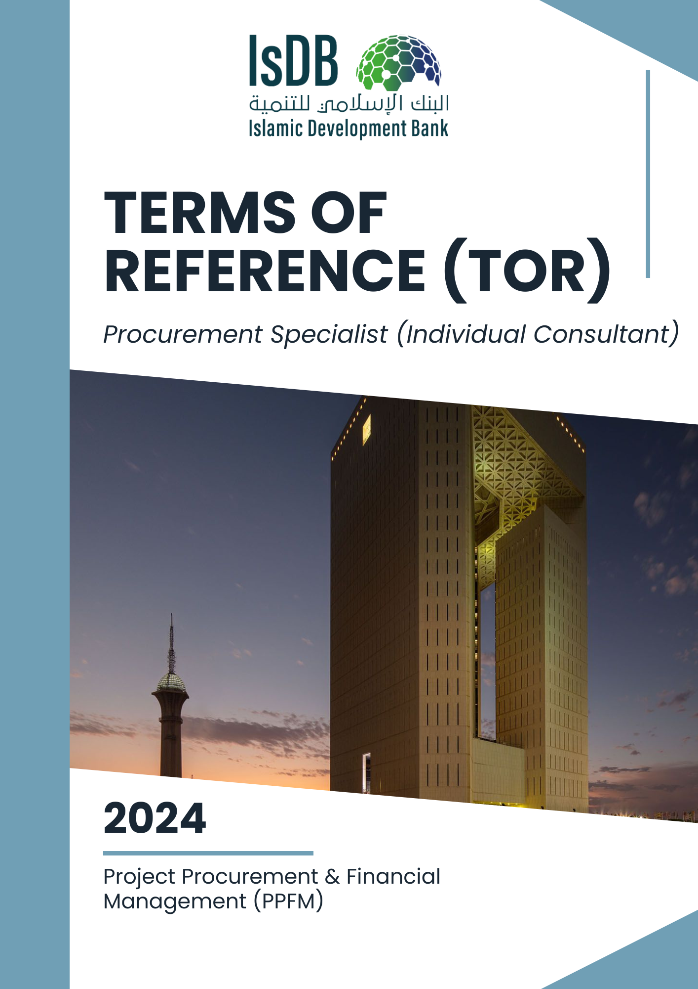

**Terms of Reference (TOR)**

Procurement Specialist

(Individual Consultant)

1. **Background**

The Islamic Development Bank (IsDB) Group is an international development financial institution, focused on fostering socio-economic development in its 57 Member Countries (MCs) across four continents (Africa, Asia, Europe, and South America). The IsDB’s mission is to promote comprehensive human development, with a focus on the priority areas of alleviating poverty, improving health, promoting education, improving governance, and prospering people.

The {*insert a brief background of the executive agency*}

1. **Project Objectives**

The Government of {*insert the Beneficiary name*} has received a {concessionary or ordinary *loan/grant}* from the Islamic Development Bank (IsDB) to finance the *{insert name of the project*}. The objective of the project is to {*insert the project objectives*}.

The project scope covers the following components: ***insert the project components***).

1. **Project Location**

The project is located at {*insert the project location*)

1. Objective of the Assignment:

The *(insert the name of executive agency*) is now seeking to hire a procurement specialist to assist in procuring works, goods, consultancy services and non-consultancy services for the effective and efficient implementation of the Project and delivering best value for money. The consultant will be selected following the procurement guidelines and procedures of the Bank {*insert the agreed guidelines*} or using the National Procurement system as per the approved project and financing agreement

The Procurement Specialist will function under the direct supervision and report to {*insert the direct supervisor position*} in the {*insert the name of the executive agency*)

1. **Scope of Work**

The Procurement Specialist will be responsible for discharging all functions pertaining to the procurement of works goods and consultancy and non-consultancy services under the Project. The Consultant’s scope of services shall include, but not limited;

1. Preparation, implementation and updating of the Procurement Implementation Manual (PPIM) as per the Prescribed Template of IsDB
2. for the project covering all goods, work, consultancy and non-consultancy services to be procured for the project based on approved mode of procurement.
3. Prepare and regularly update procurement plan for all goods, works, consultancy and non-consultancy services to be procured for the project, detailing contract packages, the estimated cost, the procurement or selection methods, market approach and timelines for each package. The procurement plan to be used for monitoring progress on procurement activities and submitted to the Bank using the e-Procurement Portal (ePP).
4. Advise and guide Project Management Unit (PMU)/Project Implementation Unit (PIU) management, related staff and stakeholders on IsDB procurement policies and guidelines.
5. Prepare and review standard procurement documents (General Public Notice (GPN),Specific Public Notice (SPN), Request for Quotation (RFQ), Request for Quotation (RFPs), Standard Bidding Documents (SBDs) and draft contracts to be submitted to IsDB for no-objection or cleared using country systems and maintained for post-review of the Bank .
6. Arrange and coordinate pre-bid meetings, prepare meeting minutes, provide written response and clarification to the queries from the bidders/consultants.
7. Coordinate and attend bid openings and prepare bid opening minutes.
8. Carry out bid/proposal evaluation and prepare , Bids Evaluation Reports (BER), Technical Evaluation Reports (TER), Combined Evaluation Reports (CER) .
9. Identify and report any suspicious activity which is red flag that might pose potential risks or lead to practices of fraud and corruption.
10. Ensure compliance with the procurement principles and requirements as per agreed the procurement process for the project.
11. Ensure transparency and integrity in the procurement processes as per the Bank’s procedure.
12. Build and enhance procurement capacity within the executing agency/PMU/PIU. This includes on-the-job training, procurement clinics and seminars on procurement and contract management related aspects.
13. Maintain close coordination and collaboration within the executing agency/PMU/PIU, relevant stakeholders and IsDB.
14. Handle complaints during various stages of the Procurement process. Ensure timely and objective resolution of the complaints. Provide comprehensive timely response to the Complainant on procurement related complaints.
15. Ensure the procurement activities are carried out in accordance with agreed procurement procedures and guidelines set out in the project financing agreement.
16. Supervise the implementation of contracts including transportation, delivery, acceptance and storage of goods.
17. Prepare and submit timely procurement activities report as per agreed format.
18. Establish and manage a central procurement record system and ensure all procurement related documents are properly recorded both in hard copy and electronic form.
19. Participate and coordinate with the various staff missions and provide required information and documents to the mission.
20. Liaise with the relevant line ministries, stakeholders and departments for the effective and efficient project implementation.
21. Contribute to the development/update of procurement policies and procedures considering the Member Countries’ needs, IsDB Group priorities and the best practices in other MDBs
22. Support in the elaboration of project concept notes, preparation and appraisal of projects in order to provide the required advice on procurement matters.
23. Contribute to development of procurement strategy for project including assessment of procurement capacity, regulations and procedures, market and risk assessments etc. which can guide procurement arrangement for project delivering best value for money.
24. Organize start-up project workshops, conduct staff briefings and provide necessary support for the procurement related aspects for projects covering various sectors.
25. Oversee the implementation of contracts to ensure that all parties adhere to the agreed terms and conditions including price escalation and contract amendments.
26. Monitor contract performance and compliance, including delivery schedules, quality of goods/services, and adherence to specifications.
27. Follow up and monitor procurement related activities and ensure timely procurement activities.
28. Conduct regular reviews and assessments of contract performance and address any issues or discrepancies.
29. Perform other work-related duties and responsibilities as may be assigned by the supervisor.
30. **Qualifications**
31. Bachelor’s or master’s degree in relevant discipline, e.g. Civil Engineering, Law, project Procurement Management, Project Management, Business Administration, Public Administration and Supply Chain Management
32. Completion of IsDB’s Project Procurement e-Learning​ modules will be an asset.
33. **Experience**
34. At least 5 years working experience in project procurement and contract management for bachelor’s degree holders and 3 years of working experience in procurement and contract management for master’s degree holders.
35. Working experience with IsDB and other MDBs financed projects will be an asset.
36. **Core Competencies**
37. Shall have effective communication skills in either of English, Arabic and French
38. Shall have effective project procurement management skills
39. Ability to handle and prioritize workload
40. Shall have effective team management skills
41. Have high standards for integrity and ethics
42. **Language Skills**
43. { Shall have effective communication skills in either of 3 Languages of the Bank i.e. English, Arabic and French}

1. **Duration of the assignment:**

The duration of the assignment will be {*insert no. of months*} months. The duration may be extended subject to availability of funds and satisfactory performance of the individual consultant.