REQUEST FOR EXPRESSION OF INTEREST
(SELECTION OF INDIVIDUAL CONSULTANTS)

Country: IsDB Member Countries
Project: Tadamon 2.0 Program
Sector: Various Sectors
INDIVIDUAL CONSULTANT SERVICES: Tadamon Project Management Specialist
Mode of Financing: Grant Financing

The Tadamon 2.0 Program has received financing from the Islamic Development Bank toward the cost of the Tadamon 2.0 Program and intends to apply part of the proceeds of this financing to eligible payments under the contract of consultant services of an Individual Consultant for which this Expression of Interest is issued.
The services include designing, managing and processing the CSOs projects under Tadamon 2.0 while ensuring that the program achieves its developmental objectives, meets its targets, and aligns with IsDB and Tadamon’ s strategic goals. This position is a professional level for 5 years and the contract will be renewable each year based on performance evaluation. The expected start date of the assignment is 1st of December 2025.
The detailed Terms of Reference (ToR) is attached in the annex.

The IsDB now invites eligible consultant (“Individual Consultants”) to indicate their interest in providing the services. Interested Consultants must provide specific information which demonstrates that they are fully qualified to perform the services. The individual consultants affiliated with an organization may also submit interest.

The shortlist will be drawn up following the evaluation of CVs and useful information in response to this notice of expression of interest including references. Potential candidates will be required to provide information on their general qualifications as an individual consultant, their mission-relevant experience, their experience in the region and sector as well as their language ability.

A consultant will be selected in accordance with the selection method applicable to Individual Consultants as defined in the IsDB Guidelines for the Procurement of Consultant Services under IsDB Project Financing (April 2019 edition)

Minimum Qualification Requirements
- Bachelor’s degree in international development, social sciences, economics, public administration, project management, or a related field.
- Minimum 5 years of experience working with NGOs, CSOs, or community‑based organizations, preferably in development or humanitarian contexts.
- Demonstrated experience in managing field activities, coordinating with local partners, and engaging directly with diverse beneficiary groups.
- Proven experience in capacity-building, including the ability to deliver training, conduct workshops, and provide technical support to CSOs.
- Strong ability to speak in public, facilitate group discussions, and communicate effectively with stakeholders from different cultural backgrounds.
- Experience in grant management, community outreach, or localization-focused initiatives is highly desirable.
- Familiarity with Islamic finance tools, digital inclusion, and innovation for development is considered an asset.
- Excellent analytical, communication, and interpersonal skills.
- Demonstrated experience managing multi-stakeholder development programs with measurable results, including budgeting, reporting, and partner or donor engagement

Excellent written and verbal communication skills:
- English (Mandatory)
- Arabic (Preferred)
- French (Preferred)

The attention of interested Individual Consultants are invited to read clauses 1.12.1 and 1.12.2 of the Procurement Policy of the IsDB Guidelines for the Procurement of Consultant Services under IsDB Project Financing, April 2019 edition (the "Procurement Guidelines") setting forth the IsDB's policy on conflicts of interest.
Interested individual consultants may obtain further information at the address below during office hours [ 09:00 to 17:00 hours] (Jeddah time).
Expressions of interest must be delivered in written form accompanied by the CV and any other document by e-mail to the address below no later than 15 February 2025.
Attention: Bakhsh Nabi Bakhsh
NGOs & Civil Society Specialist
Islamic Development Bank, Jeddah, Saudi Arabia
E-mail: BBakhsh@isdb.org, Mosafdar@isdb.org, AAbdullahi@isdb.org; ABerthe@isdb.org

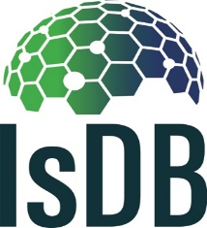

Terms of Reference (ToR)

Project Management Specialist (PMS)

IsDB NGOs Empowerment for Poverty Reduction Program- Tadamon

Phase II

2025-2030

BACKGROUND

- The IsDB Member Countries (MCs) face critical development challenges including fragility, conflict, and extreme poverty, which further economically and socially marginalize hard-to-reach and vulnerable groups. The IsDB, with its capacity to support, mobilize resources and forge strategic partnerships, plays a critical role in scaling up successful resilience programs and providing critical assistance to ensure these communities are not left behind. As a response to these historic challenges, the IsDB Group approved the Tadamon Program (phase 1), also known as the NGO Empowerment for Poverty Reduction Program in February 2019. This initiative was developed by IsDB and development partners to support the most vulnerable communities and was successfully implemented through the period 2019-2024 encouraging the Bank to further develop the program and lunch Phase 2 as Tadamon 2.0.

- Tadamon 2.0 prioritizes empowering hard-to-reach and vulnerable “last mile” communities facing barriers from isolation, fragility, conflict, or poverty. It applies innovative approaches to enhance livelihoods, build resilience, and promote economic empowerment. The developmental objective of Tadamon 2.0 (2025-2030) is to reduce poverty through improving the socio-economic well-being of hard-to-reach communities in the MCs, particularly fragile and conflict-affected countries. More specifically, the program aims at empowering communities through localization, innovation, and access to technology, while integrating community-based solutions with broader IsDB public development sector financing projects. By the end of the program, Tadamon 2.0 will benefit: (i) 500,000 hard-to-reach people accessing services (digital literacy, healthcare, skills training, and Islamic finance); (ii)16,000 low-income families benefiting from food security, and livelihood programs; and (iii) 1,500 CSOs trained through Tadamon Development Academy (TDA).

- Thus, to support Tadamon 2.0 goals and achieve its objectives, the program seeks a Project Management Specialist (PMS) who will be responsible for effectively designing, managing and processing the CSOs projects under Tadamon 2.0 while ensuring that the program achieves its developmental objectives, meets its targets, and aligns with IsDB and Tadamon’ s strategic goals.

- GOVERNANCE STRUCTURE OF THE PROGRAM

- To achieve the objectives of the Program and to ensure division of work and transparency, the Bank in consultation with different stakeholders, departments and regional hubs (of the Bank) and with some MCs, have introduced the governance structure of the Program.

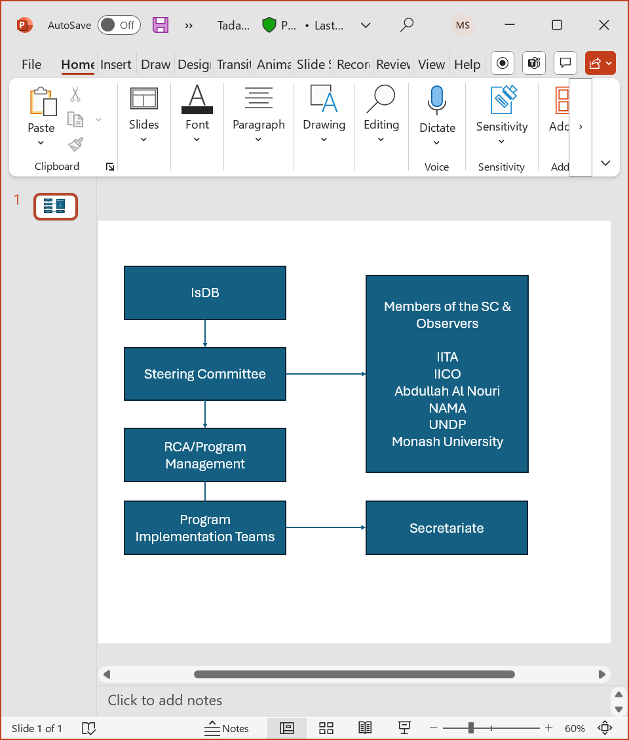

  - Strategic Steering Committee (STC): it consists of representatives from IsDB , ISFD as well as key partners, observers and the Secretariat. Partners that contribute US$ 5 million or more to the program will be members of the STC to provide strategic guidance and oversee the implementation of the program, ensuring that interventions are aligned with the program’s objectives. The STC role is to provide strategic directions, to monitor progress of action plans and to provide guidance/advice on proposed changes to the scope of the Program.

  - Program Secretariate: it is led by IsDB and supported by technical representatives of key partners. The Secretariate consists of IsDB representatives, and its roles are to implement decisions of the steering committee, review the detailed action plans, assess the progress against initial activities’ timeline, and monitor the disbursement and expenditures plan. The secretariat of this committee is entrusted to the Fragility and Resilience Division.

OBJECTIVE OF THE ASSIGNMENT
- The Project Management Specialist (PMS) will support the Tadamon Program Management Team in:

- Managing and handling the Grant projects under Tadamon 2.0 in terms of approval, design and processing until completion and closure,
- Supporting the preparation of the Annual work program.
- Supporting the Tadamon Team in the Tadamon Development Academy (TDA) to meet its objectives/targets,
- Ensuring the achievement of the Program objectives through arranging coordination meetings, annual meetings and other events for NGOs Empowerment for Poverty Reduction Program,
- Supporting the Program Coordinator in overseeing the planning, implementation, and monitoring of the Program,
- Contribute to the implementation of the Program communication and information plan,
- Supporting the team in managing the relationship with the Program partners and donors,
- Contributing to the preparation and implementation of the resource mobilization strategy of the Program,
- Contributing to the preparation of the progress reports (financial and technical) of the Program to different stakeholders internally and externally (including quarter and mid-year reports).
- Contributing to the development of Tadamon related knowledge products.

SCOPE OF WORK AND RESPONSIBILITIES
Annual Work Program
- Support the preparation of the Annual work program in collaboration with the Program Coordinator.
Project Management
- Prepare, review and process Tadamon Call for Proposals in collaboration with the Program Management Team.
- Support the Tadamon and IsDB Civil Society Teams in the end-to-end design of CSO grant projects, ensuring alignment with Tadamon 2.0 objectives and IsDB Strategy (poverty reduction, socio-economic well-being, resilience, and innovation).
- Prepare and Develop project proposals for Tadamon Grant projects, including preparing logical frameworks (logframes), budgets, and implementation plans in collaboration with local CSOs and IsDB technical teams.
- Ensure the grant projects address key themes such as localization, digital inclusion, innovation, gender equity, and climate resilience.
- Support the due diligence, compliance and capacity assessment of CSOs to ensure eligibility and readiness for funding.
- Establishing and maintaining a robust monitoring, evaluation, and learning (MEL) framework for Tadamon 2.0.
- Monitoring the progress of the Program, while ensuring that the project deliverables are on time, within budget and at the required level of quality;
- Overseeing the planning, implementation, and monitoring of activities of the Program with the different stakeholders;
- Contributing to the Program Programming, as well as dialogue with relevant financial and technical partners;
- Implementing decisions of the strategic steering committee;
- Reviewing the detailed action plans;
- Handling administrative and financial issues pertaining to the Program (processing financial request, disbursement, settlement, procurement…);
- Making field visits to the CSOs campaigns to ensure good execution of the Program by partners according to the approved terms of the Program;
- Assessing the progress against initial activities’ timeline;

Reporting & Compliance
- Ensuring timely submission of quality progress reports, financial reports, and impact assessments from CSOs.
- Tracking project-level indicators against Tadamon 2.0 program goals (e.g., service access for 500,000 people, food security for 16,000 families).
- Ensuring compliance with IsDB and donor requirements, safeguarding standards, and risk management protocols.
- Documenting and sharing best practices;
- Providing ad-hoc reports as and when needed;
Meetings, Innovation & Knowledge Development
- Identifying and documenting innovative practices, success stories, and lessons learned for internal and external dissemination.
- Preparing knowledge products in collaboration with the Tadamon Team and contributing to thought leadership, case studies, and advocacy efforts to promote community-based, technology-enabled solutions in fragile contexts.
- Managing the arrangement of different meetings such as coordination meetings between Partners and the strategic steering committee;
- Organizing local and regional events including the Annual Meetings of the Program, and Midterm review meetings;
- Preparing agenda, minutes, reports, and call for meetings;
- Coordinating the logistic arrangements with concerned units for workshops and meetings (internal and external) as well as preparing related reports;
Program Partners
- Maintaining close relationship with the CSOs and Government focal points in the MCs;
- Managing the relationship with selected financial and technical partners in coordination with the Program Coordinator.

Resource Mobilization
- Identifying potential donors and supporting donor engagement, including contributing to the preparation of partnership agreements or funding proposals, with attention to quantified targets, timelines, and documented outcomes

- Any other assignments given to him by the Program Manager.

QUALIFICATIONS AND EXPERIENCE
- Bachelor’s degree in international development, social sciences, economics, public administration, project management, or a related field.
- Minimum 5 years of experience working with NGOs, CSOs, or community‑based organizations, preferably in development or humanitarian contexts.
- Demonstrated experience managing multi-stakeholder development programs with measurable results, including budgeting, reporting, and partner or donor engagement
- Demonstrated experience in managing field activities, coordinating with local partners, and engaging directly with diverse beneficiary groups.
- Proven experience in capacity-building, including the ability to deliver training, conduct workshops, and provide technical support to CSOs.
- Strong ability to speak in public, facilitate group discussions, and communicate effectively with stakeholders from different cultural backgrounds.
- Experience in grant management, community outreach, or localization-focused initiatives is highly desirable.
- Familiarity with Islamic finance tools, digital inclusion, and innovation for development is considered an asset.
- Excellent analytical, communication, and interpersonal skills.
- Fluency in English is required. Arabic and/or French are advantages.

REQUIRED SKILLS
- Plan: Capable of developing/determining strategies to move the program forward, set goals, create and implement actions plans, and evaluate the process and results. Including making evidence-based recommendations within institutional and fiduciary constraints
- Creativity/Innovation: Ability to develop new and innovative/unique ways to improve operations of programs and to create new opportunities.
- Nurture Teamwork: Work cooperatively and effectively with others to set goals, resolve problems, and make decisions that enhance effectiveness.
- Communicate Effectively: Speak, listen and write in a clear, thorough and timely manner using proper and effective communication tools and techniques.
- Behave Ethically: Understand ethical behavior and business practices and ensure that own behavior and the behavior of others is consistent with these standards and aligns with the values of the Islamic Development Bank.
- Make Decisions: Assess situations to determine the importance, urgency and risks, and make clear decisions, which are timely and in the best interests of the Alliance.
- Organize set Priorities, develop a work plan, monitor progress towards goals, and track details/data/information/activities.
- Solve Problems: Assess problem situations to identify causes, gather and process relevant information, generate possible solutions, and make recommendations and/or resolve the problem.

- LANGUAGES
- Excellent written and spoken communication skills:
- English (Mandatory)
- Arabic (Preferred)
- French (Preferred)

GENERAL CONDITIONS OF THE CONTRACT OF THE PROJECT MANAGEMENT SPECIALIST

- CONTRACT TYPE
- Full-time position based at the IsDB HQ in Jeddah, Saudi Arabia with the possibility of working Hybrid.
- DURATION OF THE ASSIGNMENT
- The assignment is for Five years (2025-2030) and the contract is renewable every year based on the performance and the achievements of the PMS.

- REPORTING
- The PMS will report to the Fragility & Resilience Division. He/she will also work in close coordination with the Tadamon and NGO’s & Civil Society Team of the Bank, regional hubs and stakeholders and should provide regular reports about the progress of the work plans.

- OBLIGATIONS
- The PMS must complete the assignments set out in the Terms of Reference for the contract with due diligence and efficiency, in accordance with generally accepted professional techniques and practices. He/She must respect the impartiality and independence of IsDB and in connection with this contract must neither seek nor accept instructions from anyone other than the above-mentioned reporting system. During the term of this contract, the PMS must refrain from any conduct that would adversely reflect on IsDB and must not engage in any activity that is incompatible with the administrative instructions and policies and procedures of IsDB. The PMS must exercise the utmost discretion in all matters relating to this contract.

- TRAVEL
- Travel costs shall be set out in the contract, on the following basis:
(a) IsDB will pay for travel in economy class via the most direct and economical route from the Program budget,
(b) IsDB will provide the PMS with daily subsistence allowance similar to IsDB professional undertaking similar travel for official purposes, from the Program budget.

- STATEMENT OF GOOD HEALTH
- Before commencing work, the PMS must deliver to IsDB a certified self-statement of good health and take full accountability for the accuracy of that statement. He/She will be responsible for assuming all costs that may arise in relation to the statement of good health.

- Health Insurance shall be covered by the PMS.

- TERMINATION OF CONTRACT
- Either party may terminate the contract before its specified termination date by giving notice in writing to the other party. The period of notice shall be 2-3 months. In the event of impropriety or other misconduct by the PMS, IsDB shall be entitled to terminate the contract without notice.

- SELECTION AND EVALUATION CRITERIA
- The selection method for the PMS will be a competitive selection with a framework Agreement.

- A two-stage procedure will be utilized in evaluating the candidates, with evaluation of the technical candidate including the CV of the candidates and a brief proposal of 2 pages maximum (60%) and an interview of the candidates (40%).

- The contract will be negotiated/awarded to the candidate (consultant) obtaining the highest score.

- The CVs and technical criteria include the methodology, approach to undertake such assignment, the candidate relevance to the assignment, its experience in the related field as well as its key staff qualification for conducting the assignment. Minimum score of technical qualification is 75.

- The following technical scores and evaluation criteria will be used through the selection and evaluation process:

Review of the Proposal: 60%

No | Evaluation Criteria | Point
1. | Relevance to the assignment | 10
1.1 | English proficiency | 08
1.2 | Knowledge of another language and the constraint | 02
2. | Adequacy for the assignment | 40
3. | Qualifications and Competencies of the consultant in the assignment (should be from IsDB Member Countries) | 50
3.1 | General qualifications (academic profile, years of experience) | 10
3.2 | Similar experience with development program and working with NGOs and CSOs | 40
 | TOTAL | 100

Interview of the shortlisted candidates: 40%

PROPOSAL REQUIREMENTS

- SUBMISSION OF PROPOSAL

The Bank accepts CVs and Technical Proposals delivered through e-mail in PDF Format. As such, the Technical Proposal should be sent to BBakhsh@isdb.org, Mosafdar@isdb.org, AAbdullahi@isdb.org; ABerthe@isdb.org

- The email subject should clearly indicate Proposal for Project Management Specialist (PMS) for the NGOs Empowerment for Poverty Reduction Program- Tadamon 2.0. Proposals submitted after the deadline stated in the letter of invitation will not be accepted. It is suggested to submit the proposals as early as possible.

