[](https://badea.org/search-result.htm?srch=LOG%20BADEA) 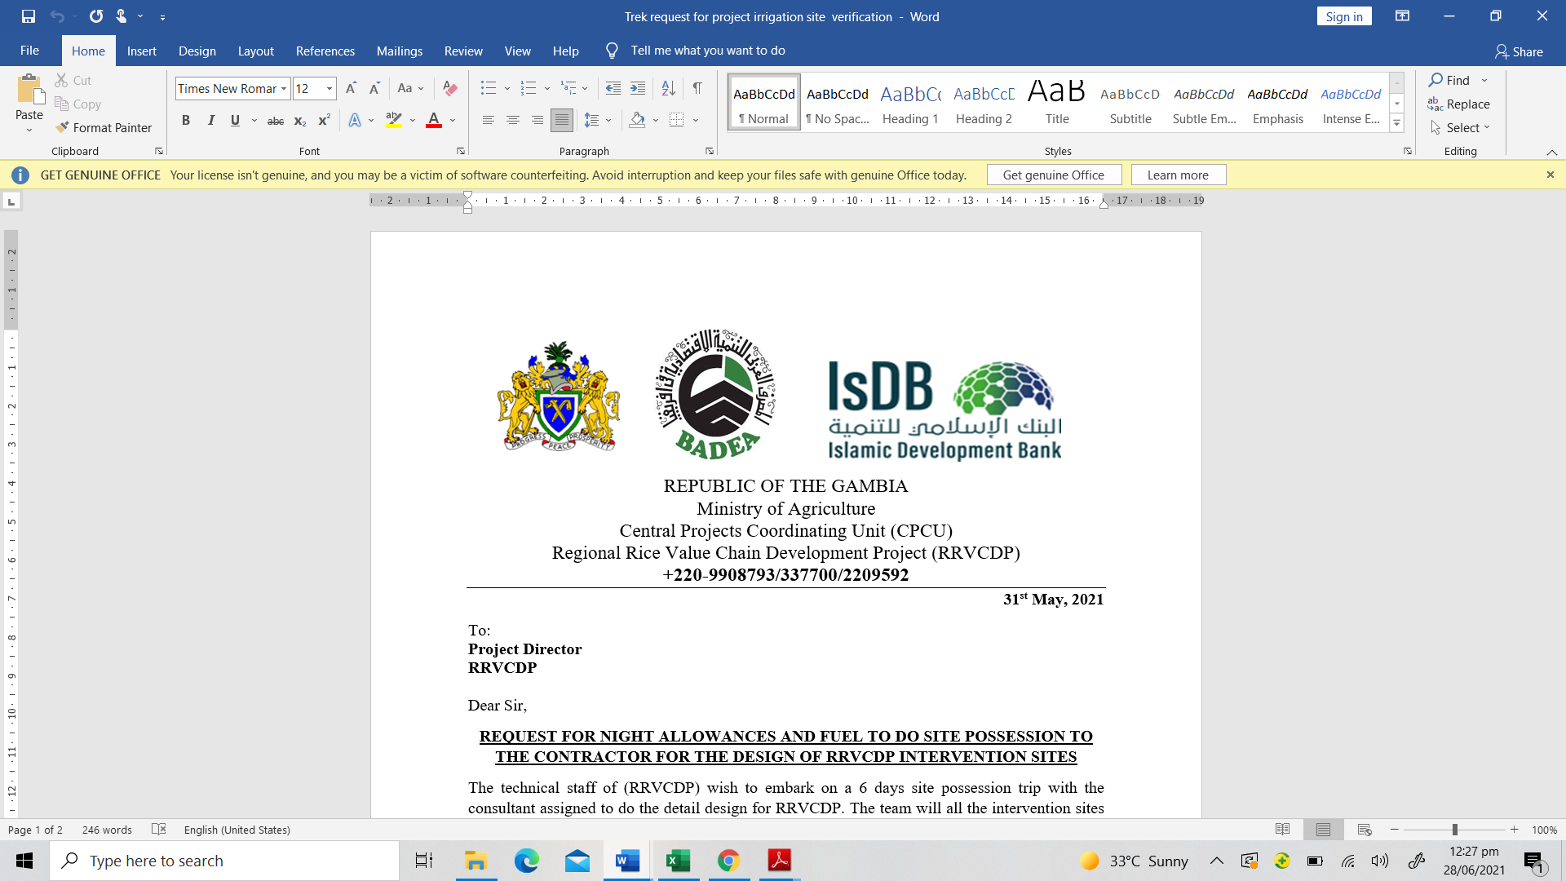 

The Republic of the Gambia `

Ministry of Agriculture

Central Projects Coordinating Unit (CPCU)

Regional Rice Value Chain Development Project (RRVCDP)

Specific Procurement Notice

The Gambia

Regional Rice Value Chain Development Project

Ministry of Agriculture

PROCUREMENT OF *WORKS*

Mode of Financing: *Loan*

Financing No. *GMB1019*

**Contract Title: *Land Development*** *(*Rehabilitation of 412ha Tidal Irrigation Facilities (Lot 1), Establishment of 575ha (New) of Pump Irrigation Facilities (Lot 2, 3 and 4), And Procurement and Installation of Solar Pump System (Lot 5) for RRVCDP/MOA)

**ICB/MC Reference No**.: ***RRVCDP/CPCU/MOA/1CB/MC/W/001***

1. The Government of the Gambia has received a loan financing from the Islamic Development Bank (IsDB) toward the cost of the Regional Rice Value Chain Development Project (RRVCDP) and intends to apply part of the proceeds toward payments under the contract [1]for cost of Land Development[2].

2. The *Ministry of Agriculture* now invites sealed bids from eligible bidders for *the* Rehabilitation of 412ha Tidal Irrigation Facilities (Lot 1), Establishment of 575ha (New) of Pump Irrigation Facilities (Lot 2, 3 and 4), And Procurement and Installation of Solar Pump System (Lot 5) *[3]*. The contract duration for each lot is 18 months and Margin of Preference is not applicable.

3. Bidding will be conducted through *the International Competitive Bidding member countries (ICB/MC)* procedures as specified in IsDB’s [*Guidelines: Procurement of Goods, Works and related services under Islamic Development Bank Project Financing*](http://www.worldbank.org/html/opr/procure/guidelin.html) *May 2019* edition revised in February 2023 (“Procurement Guidelines”), and is open to all eligible bidders as defined in the Procurement Guidelines. In addition, please refer to paragraphs 1.18 -21 setting forth IsDB’s policy on conflict of interest.

4. Interested eligible bidders may obtain further information from Project Director, Regional Rice Value Chain Development Project (RRVCDP), Central Project Coordinating Unit (CPCU), 14 Marena Parade, Banjul, *and e-mail: [fsfatajo@yahoo.com](mailto:fsfatajo@yahoo.com),* [*kummeha@gmail.com*](mailto:kummeha@gmail.com)*,* [*molpha.sanyang@gmail.com*](mailto:molpha.sanyang@gmail.com) and inspect the bidding documents during office hours *8:00 am to 16:00 hours* at the address given below[4]*.*

5. A complete set of bidding documents in English Language may be purchased by interested eligible bidders upon the submission of a written application to the address below and upon payment of a nonrefundable fee[5] of **Ten Thousand Dalasi (D10, 000).** The method of payment will be cash.[6] The document will be sent by hard copy.[7]

6. Bids must be delivered to the address below Ministry of Agriculture, Quart angle, 2nd Floor, Procurement office[8] on or before *21st January 2025.* Electronic bidding will *not* be permitted. Late bids will be rejected. Bids will be publicly opened in the presence of the bidders’ designated representatives and anyone who choose to attend at the address below Ministry of Agriculture, Quart angle, 2nd Floor, at the conference hall on ***21st January 2025 12:30pm***.

7. All bids must be accompanied by a bid security of **US$53, 578,51 Lot 1: US$66, 575.82**

**Lot 2; US$56, 854.57 Lot 3: US$31, 806.67 Lot 4: US$15, 795.77 Lot 5**

8. The address(es) referred to above is(are):

Regional Rice Value Chain Development Project (RRVCDP)

Attn: Mr. Fafanding S. Fatajo, Project Director

14 Marena Parade, Banjul and The Gambia

Tel: 00220 3377000/3411433/9966763

E-mail: [fsfatajo@yahoo.com/](mailto:fsfatajo@yahoo.com/) [kummeha@gmail.com/](mailto:kummeha@gmail.com/) [molpha.sanyang@gmail.com](mailto:molpha.sanyang@gmail.com)

1.
2.
3.
4.
5.
6.
7.
8.