**Invitation for Expression of Interest (IEOI) – Individual Consultant**

**Invitation for Expression of Interest**

*Date 22/08/2024*

**Hiring a Consultant for Operational Monitoring and Physical Inspection of Medical Mobile Clinics and their Associated Equipment and Trailers in Kyrgyz Republic and Tajikistan.**

1. The Islamic Development Bank (IsDB) is hiring individual consultant to extend the consultancy services (STC) assignment to further cover the operational monitoring and supervision as well as regular inspection of Medical Mobile Units (MMUs) and their associated equipment and trailers as well as the ambulances and supporting vehicles in both Tajikistan and Kyrgyzstan.

2. The Terms of Reference (TOR) of the Services are attached and can be obtained by emailing [kaldheeb@isdb.org](mailto:kaldheeb@isdb.org) (cc: [KAAP@isdb.org](mailto:KAAP@isdb.org) and [arkenzhegulov@isdb.org](mailto:arkenzhegulov@isdb.org) ). IsDB will select and engage the Consultants in accordance with the IsDB Corporate Procurement Policy.

2. IsDB now invites Expression of Interest (EOI) and proposal from potential individual applicants for consideration by IsDB in selecting the consultant.

3. Applicants who wish to submit an EOI for proposal should complete the EOI Forms in Annex-II and submit it through email to the following authorized representatives of IsDB by **21 September 2024**:

Khaled Al Dheeb

Head of Administration

Regional Hub of Almaty

Islamic Development Bank

Email: [kaldheeb@isdb.org](mailto:kaldheeb@isdb.org)

Phone: +7 727 2727000

**Encl.:**

**Annex-I:** Terms of Reference

**Annex-II:** EOI Form

**Annex-I**

**TERMS OF REFERENCE**

**for Short Term Consultancy Services for Operational Monitoring and Physical Inspection of Medical Mobile Clinics and their Associated Equipment and Trailers in Kyrgyz Republic and Tajikistan.**

1. **BACKGROUND**

The Islamic Development Bank (IsDB) through the Almaty Regional Hub (ROA) would like to extend the consultancy services (STC) assignment to further cover the operational monitoring and supervision as well as regular inspection of Medical Mobile Units (MMUs) and their associated equipment and trailers as well as the ambulances and supporting vehicles in both Tajikistan and Kyrgyzstan. The following are the main elements of this exercise:

|  |  |
| --- | --- |
| The Project | Mobile Clinics Units Project for Tajikistan and Kyrgyzstan. |
| Location | IsDB Regional Hub Almaty |
| Frequent Travel to | Tajikistan, Kyrgyzstan, and other countries as deemed needed |
| Duration of the assignment | One Year (extendable) |
| Starting Date of the assignment | During 2024, the exact date is to be announced (TBA) |

1. **DEFINITION**

Islamic Development Bank (IsDB) is an international Islamic financial institution[1]. The IsDB is implementing a project for both Tajikistan and Kyrgyzstan under the Mobile Clinic Units (MMUs) Program. Within the scope of this project, 10 (ten) MMUs were delivered to Tajikistan and Kyrgyzstan (5 each) in order to assist these two countries to meet lack of health services in remote rural areas. The service provider of these MMUs is Normeca, Norway (the service provider).

1. **THE BACKGROUND**

The production of the MMUs main bodies started by the end of 2019 in two factories, in Ankara and Sakarya in Turkey, by Optima and Alkan Group, respectively. All medical and non-medical equipment, as well as the furniture, were either procured from the local market or imported from the EU or Asia. Production concluded during February 2021. All MMUs and associated components were delivered to both Kyrgyzstan and Tajikistan during May and June 2021, respectively. The MMUs are working in both countries. For the MMUs Project in Kyrgyz, all MMUs are rotating together within the country to provide medical services as a mini mobile hospital while in Tajikistan they are working in 4 different locations as mobile medical units in each location.

1. **THE SCOPE of the ASSIGNMENT**

IsDB would like to hire an individual consultant with a medical background to be attached for this project as full-time monitoring and supervision consultant. The main assignment is to monitor and supervise the MMUs operation in the two countries as well as to inspect the physical assets from time to time as per the signed agreement with the service provider. The following are the main scope of this assignment:

1. Physical frequent visit to both countries, i.e. Kyrgyzstan and Tajikistan.
2. Monitor and supervise the MMUs’ operation physically and remotely.
3. Comprehensive inspection of all MMUs and their associated trailers and equipment installed inside and outside. This will include the ambulances, minibuses and other supporting vehicles.
4. Review the medical and technical details of the MMUs and their requirements based on the signed agreement with the service provider.
5. Verification that the MMUs medical and non-medical equipment, furniture and other fixtures are meeting the safety, regulations and standards of both countries as well as after-sales services.
6. Ensuring the quality of the medical services.
7. In coordination with service provider, ensuring maximum delivery of services and optimum usage of equipment and facilities.
8. Random check/verify patients records and their responses.
9. Verify and ensure that all MMUs and related components are working safely and operating in excellent condition.
10. Ensure that medical waste disposal meets international/national regulations and standards.
11. Participate and facilitate in project evaluations (when needed) by IsDB’s Independent Evaluation Department (IEvD).
12. Communications and branding (visibility) of the project.
13. Make unannounced (surprise) visits to the project locations.

Attached are sample images for the MMUs/trucks related to the project.

1. **DURATION OF WORK**

It is envisaged that the consultant will have a contract for 12 months (extendable subject to the performance of the Consultant and project duration).

**EXPECTED OUTPUTS and DELIVERABLES**

1. The consultant will produce the following major outputs (in English):
   1. An Inception Report detailing methodology, structure of reporting formats and work plan for a year at the beginning of the assignment ~~exercise~~.
   2. Monthly monitoring and supervision report including all elements and services mentioned in the TOR supported with images and videos.
   3. Quarterly project progress report on statistical elements and services mentioned in the TOR.
   4. Report immediately any defects or problems in operation or physical assets.
   5. Suggest Corrective measures to be taken by the service provider (if any).
   6. Review, verify and comment on the disbursement related to the project.
   7. Help in communications, reporting and branding of the MMUs Project.
   8. Prepare related Presentations when needed.
   9. At the end of the assignment comprehensive reports with Executive summary in 3 pages in English.
2. **Related to the Assignment:**
3. The assignment shall be over the period indicated above with at least one visit per month to each country for the MMUs Project.
4. The consultant will be supervised by KAAP-IsDB team. The KAAP team will provide overarching supervision to the assignment and will provide feedback and guidance to achieve the goal and specific objectives of this assignment when needed.
5. All deliverables are expected to be finalized through rigorous consultative meetings and in-depth discussions with the stakeholders and key partners.
6. Developed and properly filled checklist for the assignment.
7. Comprehensive inspection reports.

The reports produced in this assignment will be a vital document to serve as a basis for operational monitoring and supervision. A series of meetings might be conducted with the consultant in English to discuss the outcomes of the exercise.

1. **CONSULTANT QUALIFICATIONS**

The assignment covers different aspects/fields. However, the main fields are related to medical services and project management. The consultant must have a minimum of master’s degree in relevant field with at least 10 years of experience; Experience in handling similar consultancy tasks and advanced knowledge of English. The applicant should provide a declaration to confirm that they have no relation/interests with the service provider (Normeca) or the factories (Optima/Alkan) or Tajikistan and Kyrgyzstan. The consultant with experience in management of similar nature of facilities including medical devices and equipment is preferable.

The interested applicant needs to provide an updated CV (e.g. curriculum vitae, certificates, professional experience) and at least three references to be contacted as needed.

1. **PAYMENT TERMS:**
2. The total cost to cover this assignment is proposed to be paid on monthly basis (linked to deliverables as defined above) as a lump sum to cover all expenses including all professional fees, travel expenses, tickets, visas, insurances as well as taxes, etc.
3. Final payment of the last month will be paid after completion and receiving the final report of the assignment.
4. **IMPERATIVE POINTS:**
5. The consultant will gather and find out a way to access all required documents/information related to the assignment.
6. Logistics: the consultants will make necessary arrangements related to travel, visas and field visits, etc. in coordination with the Almaty Regional Hub.
7. The consultant should arrange his own travel insurance and Visas (if any) during the travel.
8. The IsDB evaluation of the submitted reports will be final.
9. Confidentiality: the consultant shall not, during the term of this Contract and within 5 years after its expiration, disclose any proprietary or confidential information relating to the Services, this Contract or the IsDB's business or operations without the prior written consent of the IsDB.
10. Ownership of Material: Any studies report or other material, graphic, software or otherwise, prepared by the Consultant for the IsDB under this Contract shall belong to and remain the property of the IsDB.

**Sample Images from the field.**

**TAJIKISTAN (MMU I - Konibodom District, Shugd Region)**

**Images taken in location (changeable) :** [**http**](https://maps.app.goo.gl/xmVRRE3gA2wtiCSA8)**s://maps.**[**a**](https://maps.app.goo.gl/xmVRRE3gA2wtiCSA8)**pp.go**[**o.**](https://maps.app.goo.gl/xmVRRE3gA2wtiCSA8)**gl/x**[**mV**](https://maps.app.goo.gl/xmVRRE3gA2wtiCSA8)**R**[**R**](https://maps.app.goo.gl/xmVRRE3gA2wtiCSA8)**E3gA2wti**[**C**](https://maps.app.goo.gl/xmVRRE3gA2wtiCSA8)**SA8**

|  |  |  |
| --- | --- | --- |
|  |  | |
|  |  |  |

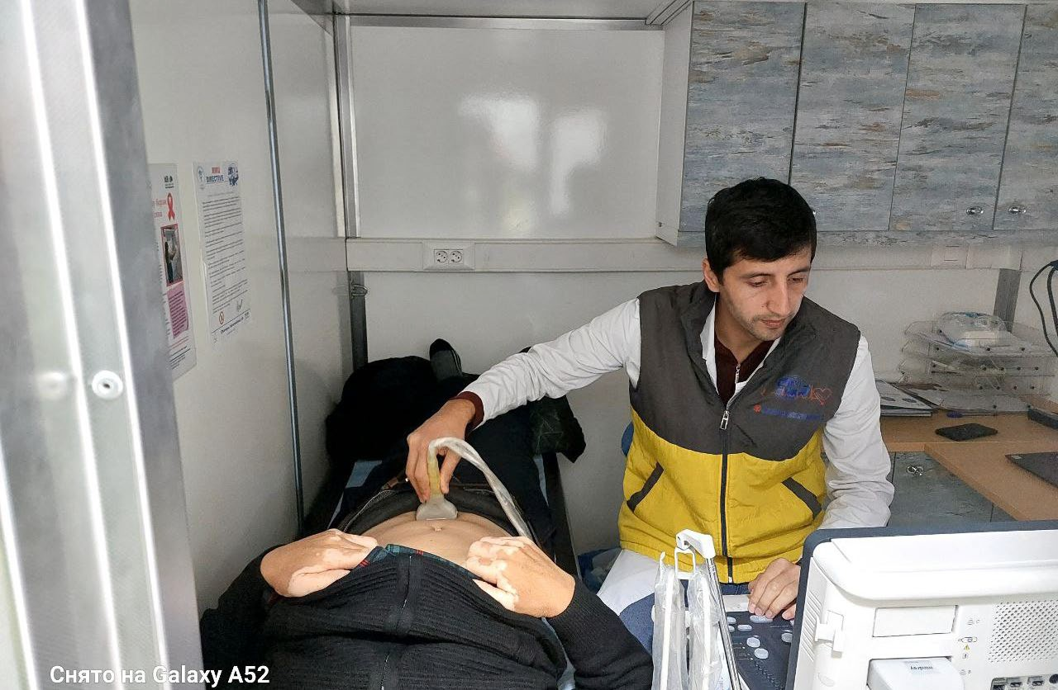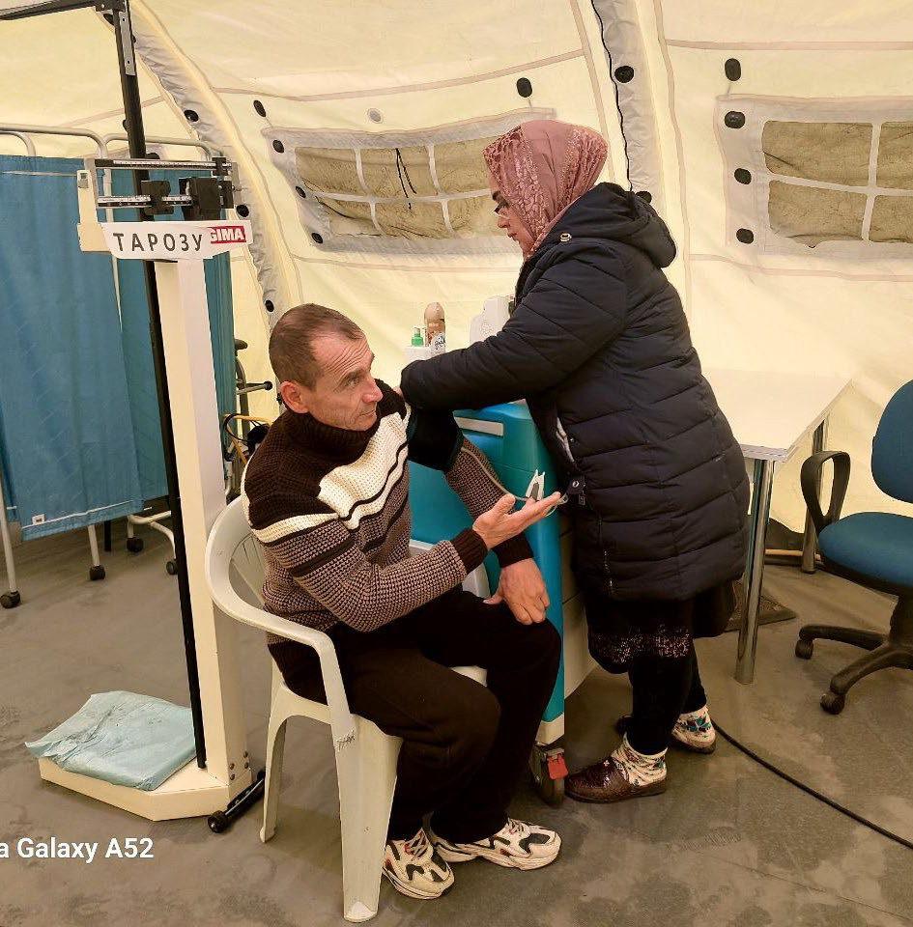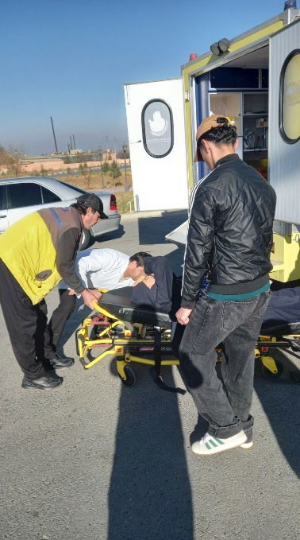

**MMU III - Vakhshstroy, Khatlon Region**

**Current location :** [**https://**](https://maps.app.goo.gl/irD4jKBVDGr2gSNW6)**maps.ap**[**p**](https://maps.app.goo.gl/irD4jKBVDGr2gSNW6)**.goo.gl**[**/**](https://maps.app.goo.gl/irD4jKBVDGr2gSNW6)**ir**[**D**](https://maps.app.goo.gl/irD4jKBVDGr2gSNW6)**4jKBVDG**[**r**](https://maps.app.goo.gl/irD4jKBVDGr2gSNW6)**2gSNW6**

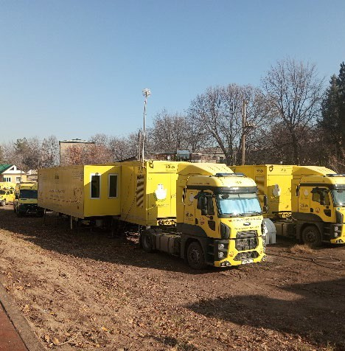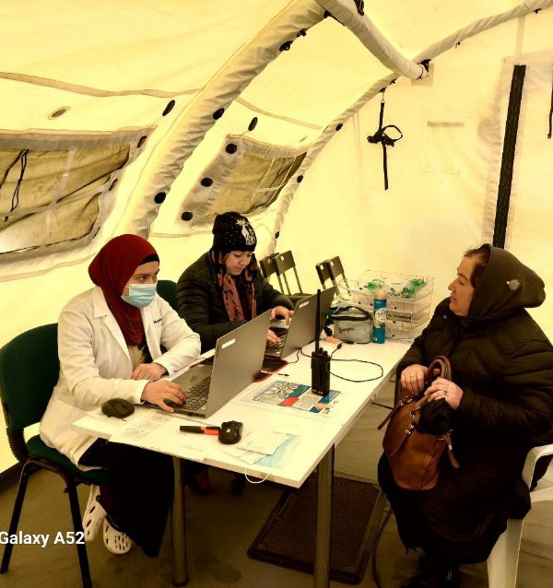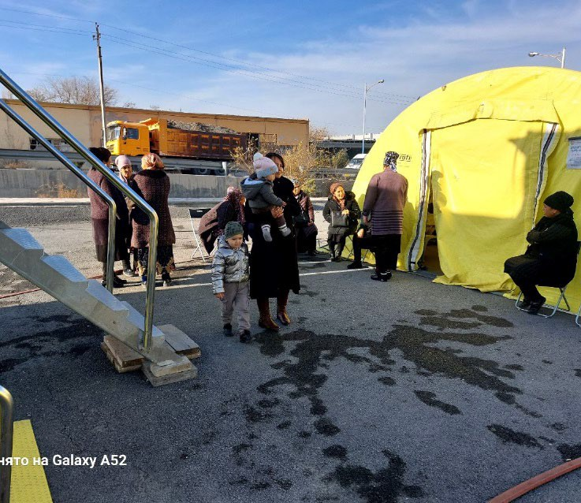

**Images taken in location (changeable) :** [**https://m**](https://maps.app.goo.gl/QGYPqZPinc31jQGa6)**aps.ap**[**p**](https://maps.app.goo.gl/QGYPqZPinc31jQGa6)**.goo.gl**[**/**](https://maps.app.goo.gl/QGYPqZPinc31jQGa6)**Q**[**G**](https://maps.app.goo.gl/QGYPqZPinc31jQGa6)**YPqZPinc**[**3**](https://maps.app.goo.gl/QGYPqZPinc31jQGa6)**1jQGa6**

|  |
| --- |
|  |

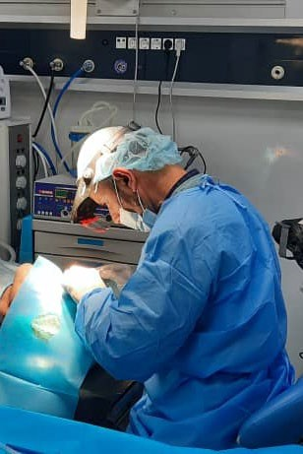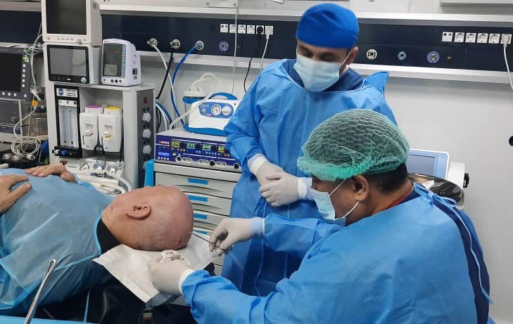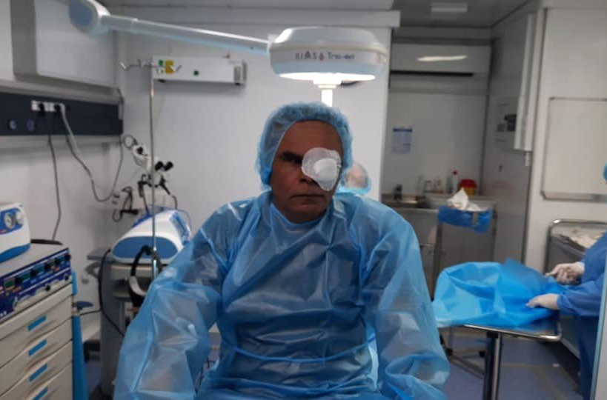

**List of MMus and Vehicles for each Country**

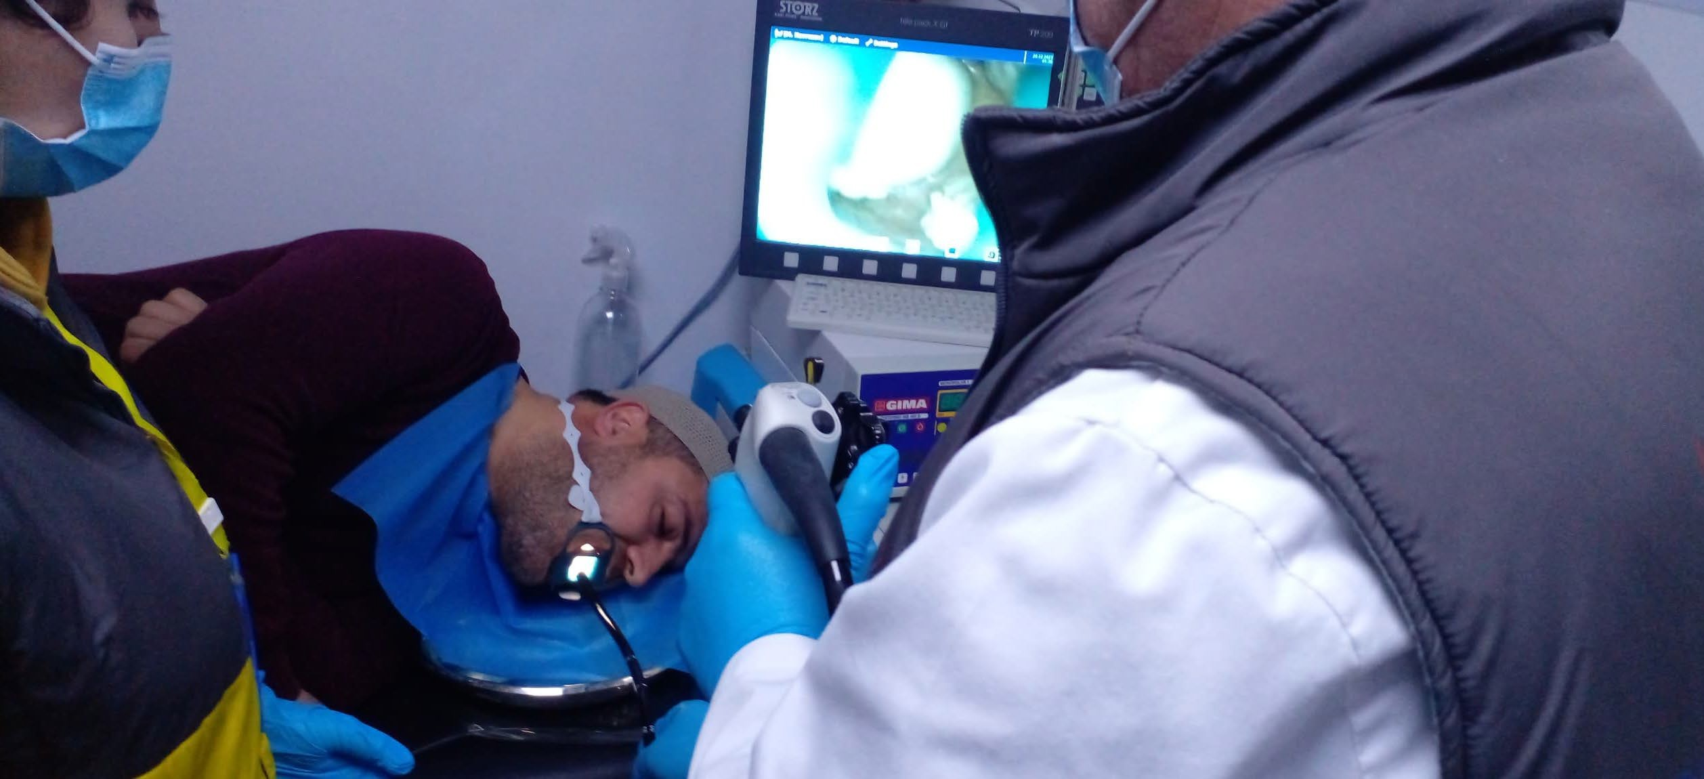

**MMUs and Vehicles to Kyrgyzstan**

|  |  |  |  |  |  |  |  |  |
| --- | --- | --- | --- | --- | --- | --- | --- | --- |
| **No** | **Model** | **Vehicle Type** | **Number of Seats** | **Chassis or VIN No.** | **Year** | **Plate** | **Trailer #** | **Trailer Description** |
| **1** | **Ford** | **Trucks** | **2** | **NM0KCXTP6KLK94025** | **2020** | **0777 I0** | **K-01** | **Multi Diagnostic Center** |
| **2** | **Optima** | **Trailer** | **0** | **NP9AL2YA7LA016052** | **2021** | **0776 I0** | **K-01** | **Multi Diagnostic Center** |
| **3** | **Ford** | **Trucks** | **2** | **NM0KCXTP6KLK93999** | **2020** | **0778 I0** | **K-02** | **Recovery & Laboratory** |
| **4** | **Optima** | **Trailer** | **0** | **NP9AL2YA7LA016051** | **2021** | **0779 I0** | **K-02** | **Recovery & Laboratory** |
| **5** | **Ford** | **Trucks** | **2** | **NM0KCXTP6KLK94040** | **2020** | **0771 I0** | **K-03** | **CT Scan & Mammography** |
| **6** | **Alkan** | **Trailer** | **0** | **NR9AY3FH1L1078012** | **2021** | **0770 I0** | **K-03** | **CT Scan & Mammography** |
| **7** | **Ford** | **Trucks** | **2** | **NM0KCXTP6KLK93998** | **2020** | **0768 I0** | **K-04** | **Surgery, Endoscopy & Dental** |
| **8** | **Optima** | **Trailer** | **0** | **NP9AL2YA7LA016053** | **2021** | **0769 I0** | **K-04** | **Surgery, Endoscopy & Dental** |
| **9** | **Ford** | **Trucks** | **2** | **NM0KCXTP6KLK93997** | **2020** | **0783 I0** | **K-05** | **Screening & Command** |
| **10** | **Optima** | **Trailer** | **0** | **NP9AL2YA7LA016048** | **2021** | **0782 I0** | **K-05** | **Screening & Command** |
| **11** | **Ford** | **Trucks** | **2** | **NM0KCXTP6KLK93996** | **2020** | **0773 I0** | **K-06** | **Accommodation** |
| **12** | **Optima** | **Trailer** | **0** | **NP9AL2YA7LA016049** | **2021** | **0772 I0** | **K-06** | **Accommodation** |
| **13** | **Ford** | **Trucks** | **2** | **NM0KCXTP6KLK93995** | **2020** | **0774 I0** | **K-07** | **Accommodation** |
| **14** | **Optima** | **Trailer** | **0** | **NP9AL2YA7LA016050** | **2021** | **0775 I0** | **K-07** | **Accommodation** |
| **15** | **Ford** | **Trucks** | **2** | **NM0KCXTP6KLK93994** | **2020** | **0781 I0** | **K-08** | **Kitchen & Laundry** |
| **16** | **Alkan** | **Trailer** | **0** | **NR9AY2FH1L1078013** | **2021** | **0780 I0** | **K-08** | **Kitchen & Laundry** |
| **17** | **Mercedes** | **Minibus** | **21** | **WDB9076571P135018** | **2020** | **4344 IM** | **K-10** | **Support vehicle** |
| **18** | **Mercedes** | **Minibus** | **21** | **WDB9076571P171902** | **2020** | **4345 IM** | **K-11** | **Support vehicle** |

**MMUs and Vehicles to Tajikistan**

| **No.** | **Model** | **Vehicle Type** | **Number of Seats** | **Chassis or VIN No.** | **Year** | **Plate** | **Trailer #** | **Trailer Description** |
| --- | --- | --- | --- | --- | --- | --- | --- | --- |
| **1** | **Ford** | **Trucks** | **2** | **NM0KCXTP6KLK94101** | **2020** |  | **T-01.01** | **Multi Diagnostic Center 1** |
| **2** | **Optima** | **Trailer** | **0** | **NP9AL2YA7LA016044** | **2021** |  | **T-01.01** | **Multi Diagnostic Center 1** |
| **3** | **Ford** | **Trucks** | **2** | **NM0KCXTP6KLK94105** | **2020** |  | **T-01.02** | **Multi Diagnostic Center 2** |
| **4** | **Alkan** | **Trailer** | **0** | **NR9AY2FH1L 1078009** | **2021** |  | **T-01.02** | **Multi Diagnostic Center 2** |
| **5** | **Ford** | **Trucks** | **2** | **NM0KCXTP6KLK94106** | **2020** |  | **T-01.03** | **Multi Diagnostic Center 3** |
| **6** | **Optima** | **Trailer** | **0** | **NR9AY2FH1L 1078010** | **2021** |  | **T-01.03** | **Multi Diagnostic Center 3** |
| **7** | **Ford** | **Trucks** | **2** | **NM0KCXTP6KLC93542** | **2020** |  | **T-02.04** | **Surgery, Gastroenterologi & X-ray** |
| **8** | **Alkan** | **Trailer** | **0** | **NR9AY2FH1L 1078011** | **2021** |  | **T-02.04** | **Surgery, Gastroenterologi & X-ray** |
| **9** | **Ford** | **Trucks** | **2** | **NM0KCXTP6KLK94041** | **2020** |  | **T-03.05** | **CT Scan & Mammography** |
| **10** | **Alkan** | **Trailer** | **0** | **NP9AL3YA7LA016027** | **2021** |  | **T-03.05** | **CT Scan & Mammography** |
| **11** | **Ford** | **Trucks** | **2** | **NM0KCXTP6KLK93992** | **2020** |  | **T-05.01** | **Accommodation 1** |
| **12** | **Alkan** | **Trailer** | **0** | **NR9AY2FH1L 1078005** | **2021** |  | **T-05.01** | **Accommodation 1** |
| **13** | **Ford** | **Trucks** | **2** | **NM0KCXTP6KLC93544** | **2020** |  | **T-05.02** | **Accommodation 2** |
| **14** | **Alkan** | **Trailer** | **0** | **NR9AY2FH1L 1078006** | **2021** |  | **T-05.02** | **Accommodation 2** |
| **15** | **Ford** | **Trucks** | **2** | **NM0KCXTP6KLK93993** | **2020** |  | **T-05.03** | **Accommodation 3** |
| **16** | **Alkan** | **Trailer** | **0** | **NR9AY2FH1L 1078007** | **2021** |  | **T-05.03** | **Accommodation 3** |
| **17** | **Ford** | **Trucks** | **2** | **NM0KCXTP6KLK94036** | **2020** |  | **T-05.04** | **Accommodation 4** |
| **18** | **Alkan** | **Trailer** | **0** | **NR9AY2FH1L 1078008** | **2021** |  | **T-05.04** | **Accommodation 4** |
| **19** | **Toyota** | **Ambulance** | **3** | **MR0DB9CB1L4970192** | **2020** |  | **T-06.01** | **Support vehicle (Ambulance)** |
| **20** | **Toyota** | **Ambulance** | **3** | **MR0DB9CB9L4970196** | **2020** |  | **T-06.02** | **Support vehicle (Ambulance)** |
| **21** | **Toyota** | **Ambulance** | **3** | **MR0DB9CB1L4970189** | **2020** |  | **T-06.03** | **Support vehicle (Ambulance)** |
| **22** | **Toyota** | **Ambulance** | **3** | **MR0DB9CB6L4970205** | **2020** |  | **T-06.04** | **Support vehicle (Ambulance)** |
| **23** | **Ford** | **Trucks** | **2** | **NM0KCXTP6KLK94102** | **2020** |  | **T-07.01** | **Kitchen & Laundry 1** |
| **24** | **Alkan** | **Trailer** | **0** | **NR9AY2FH1L 1078001** | **2021** |  | **T-07.01** | **Kitchen & Laundry 1** |
| **25** | **Ford** | **Trucks** | **2** | **NM0KCXTP6KLK94104** | **2020** |  | **T-07.02** | **Kitchen & Laundry 2** |
| **26** | **Alkan** | **Trailer** | **0** | **NR9AY2FH1L1078002** | **2021** |  | **T-07.02** | **Kitchen & Laundry 2** |
| **27** | **Ford** | **Trucks** | **2** | **NM0KCXTP6KLK94103** | **2020** |  | **T-07.03** | **Kitchen & Laundry 3** |
| **28** | **Alkan** | **Trailer** | **0** | **NR9AY2FH1L1078003** | **2021** |  | **T-07.03** | **Kitchen & Laundry 3** |
| **29** | **Ford** | **Trucks** | **2** | **NM0KCXTP6KLC93543** | **2020** |  | **T-07.04** | **Kitchen & Laundry 4** |
| **30** | **Alkan** | **Trailer** | **0** | **NR9AY2FH1L1078004** | **2021** |  | **T-07.04** | **Kitchen & Laundry 4** |
| **31** | **Mercedes** | **Minibus** | **21** | **W1V9976571P214619** | **2020** |  | **T-08.01** | **Support vehicle** |
| **32** | **Mercedes** | **Minibus** | **21** | **WDB9076571P167605** | **2020** |  | **T-08.02** | **Support vehicle** |
| **33** | **Mercedes** | **Minibus** | **21** | **WDB9076571P173491** | **2020** |  | **T-08.03** | **Support vehicle** |
| **34** | **Mercedes** | **Minibus** | **21** | **WDB9076571P167913** | **2020** |  | **T-08.04** | **Support vehicle** |

**Others: The following vehicles are yet to be delivered to their final destination:**

**Kyrgyzstan:**

**2 x Toyota Hi Lux Pickup 4 x 4 diesel double cabin special reinforced**

**1 x Toyota Hi Lux Pickup single cabin 4 x 4 diesel with ambulance box and special reinforced**

**Tajikistan:**

**5 x Toyota Hi Lux Pickup 4 x 4 diesel double cabin special reinforced**

**1 x Toyota Fortuner 4 x 4 diesel, 7 seats special reinforced**

**\*\*\***

**Annex-II: Expression of Interest (EOI) by Applicant**

**Hiring a Consultant for Operational Monitoring and Physical Inspection of Medical Mobile Clinics and their Associated Equipment and Trailers in Kyrgyz Republic and Tajikistan**

Date: ________________

Khaled Al Dheeb

Head of Administration

Regional Hub of Almaty

Islamic Development Bank

Email: [kaldheeb@isdb.org](mailto:kaldheeb@isdb.org)

Phone: +7 727 2727000

I have read carefully your Invitation for Expression of Interest for the captioned assignment/project and find the Terms of References (TOR) and Scope of Work match my skill mix and experiences for providing the services required in the TOR. I would like to express my interest being considered for the Shortlist. I understand that IsDB does not have an obligation that I must be shortlisted.

I have attached to this EOI supporting documents highlighting the relevant expertise and Experience for your consideration. Some of the key information is highlighted below:

1. **Personal Profile** :

|  |
| --- |
| Nationality:  Date of Birth:  Permanent Address:  Phone No.:  Email: |

1. **Qualification of the Consultant:**

*Notes to consultant: Please indicate all relevant qualifications and professional accreditations that make you suitable for the assignment. Indicate relevant qualification, place from where the qualification was obtained, year etc]*

1. **Past Job/Consultancy Assignment References**

*[Notes to consultant: Please select most relevant consultancy assignments you have recently completed to demonstrate your technical qualifications and experience. ]*

|  |  |  |  |  |  |
| --- | --- | --- | --- | --- | --- |
| Period | Client | Project | Country | Your role (As lead consultant or as member of a team?) | Value of the  Contract |
|  |  |  |  | *Can elaborate further below* |  |
|  |  |  |  |  |  |
|  |  |  |  |  |  |
|  |  |  |  |  |  |
|  |  |  |  |  |  |
|  |  |  |  |  |  |

1. **Eligibility Declaration**

I, the undersigned, certify to the best of my knowledge and belief:

I have read terms of reference (TOR) for this assignment and the Scope of the assignment therein.

I confirm that the project references submitted as part of this EOI accurately reflect the experience of myself.

I confirm that I have never been convicted of an integrity-related offense or crime related to theft, corruption and fraud.

I understand that any misrepresentations that knowingly or recklessly mislead or attempt to mislead may lead to the automatic rejection of the proposal or cancellation of the contract, if awarded, and may result in further remedial action, in accordance with IsDB’s Integrity and Anti-corruption Policy.

I shall be available for the assignment as per the requirements

1. **Attach CV of yourself**

Signature Name-Surname

1. More information can be obtained from our website: <https://www.isdb.org>.