**Invitation for Expression of Interest (IEOI) – Individual Consultant**

*Date 26/08/2022*

**Hiring a Consultant for Need Assessment and National Curriculum Rollout and Teaching-Learning Material Development in Tajikistan under the Joint IsDB-GPE-OFID Project for support to implementation of National Education Development Strategy of Tajikistan (Phase-II)**

1. The Islamic Development Bank (IsDB) is hiring individual consultant for conducting need assessment and preparing the Joint IsDB-GPE-OFID Project for support to implementation of National Education Development Strategy of Tajikistan (Phase-II). The Terms of Reference (TOR) of the Services is attached and can be obtained by emailing [mkahagh@isdb.org](mailto:mkahagh@isdb.org) (cc: amkhan@isdb.org). IsDB will select and engage the Consultant in accordance with the IsDB Corporate Procurement Policy.

2. IsDB now invites Expression of Interest (EOI) and proposal from potential individual applicants for consideration by IsDB in selecting the consultant.

3. Applicants who wish to submit an EOI with proposal should complete the EOI Form in Annex-II or obtain the template by writing to [mkahagh@isdb.org](mailto:mkahagh@isdb.org) (cc: amkhan@isdb.org) and submit it through email to the following authorized representatives of IsDB by 5th September 2022:

Muhammad Mirzaei Kahagh

Operations Team Leader

Regional Hub of Almaty

Islamic Development Bank

Email: [mkahagh@isdb.org](mailto:mkahagh@isdb.org) / amkhan@isdb.org

Mobile: +77018005910

**Encl.:**

**Annex-I:** Terms of Reference

**Annex-II:** EOI Form

**Annex-**III: Template of Project Document

**Annex-I: TERMS OF REFERENCE**

**For Individual Consulting services for National Curriculum Rollout and Teaching-Learning Material Development in Tajikistan**

1. **Background:**
2. The Islamic Development Bank (IsDB) is a multilateral development finance institution, focused on fostering socio-economic development in its 57 Member Countries (MCs) across four continents (Africa, Asia, Europe, and South America). The IsDB mission is to promote comprehensive human development, with a focus on the priority areas of alleviating poverty, improving health, promoting education, improving governance and prospering people.
3. The Global Partnership for Education (GPE), established in 2002, has evolved over the years as the leading global partnership focused on education in developing countries. The mission of the GPE is to galvanize and coordinate a global effort to ensure access to inclusive, equitable, and quality education for all children. The GPE mobilizes international financing and promotes efficient use of international and national resources to support developing countries' education goals and sector strategies.
4. The OPEC Fund for International Development (OFID) was established by the member countries of OPEC in 1976 with a distinct purpose to drive development, strengthen communities and empower people. Its work is people-centered, focusing on financing projects that meet essential needs, such as food, energy, infrastructure, employment, clean water and sanitation, healthcare, and education.
5. Tajikistan has in recent years made significant progress in primary education by increasing enrolment and closing the gender parity gap. Access of children to primary education and share of children completing the primary cycle without dropping out of the educational process significantly improved. Despite these remarkable improvements in access and participation, enhancing education quality through improvements in curriculum efficacy, teaching quality and learning outcomes remains a challenge. Teaching pedagogy and assessments are largely content-focused; and not competency-oriented as ideal. Their alignment with curricular content and expectations are equally weak. There is therefore the necessity for effective interventions for quality improvement and alignment of curriculum and teaching-learning processes with emphasis on learning content, pedagogy, and assessment to ensure all children have qualitative learning experiences for achieving optimal learning outcomes.
6. The Government of Tajikistan developed the National Strategy for Education Development (2030) to guide its efforts in addressing challenges in the modernization of the education sector. The NSED aims at ensuring access to quality education, structural reforms in the education system, modernization of educational content, increasing school attendance rates and addressing inequalities. The NSED has been translated to the Medium-Term Education Implementation Plans (MTEIP) including operational plans for implementation of the education priorities of the NSED.
7. A Partnership Compact document for transforming Tajikistan education system in line with the NSED has been developed with financial support GPE and technical expertise from UNICEF and other development partners.
8. The partnership compact is aimed at facilitating Tajikistan government-led partnerships with development partners and coordination mechanisms to mobilize of adequate financial resources and programming support for the effective implementation of NSED. Within the framework of the compact, the government of Tajikistan, GPE and IsDB are partnering to design and implement a proposed US$ 86 million education development assistance project to support NSED implementation. The GPE has allocated US$ 25 million (US$ 15 million multiplier fund grant and US$ 10 million system transformation grant) to the Republic of Tajikistan for the project. IsDB has allocated US$ 45 million to meet the GPE’s multiplier fund requirement and the OFID has committed US$ 8 million to co-finance the project. The Government of Tajikistan has committed to contributing US$ 8 million amounting to US$ 86 million project funding provision.
9. **Rationale for the Consultancy:**
10. Unless the curricular design and assessment practices are strong enough with a focus on child-centered, activity-based pedagogy and competency-based assessment, learning deficits and inequality will continue to persist and possibly widen. The revision of the curriculum and its effective implementation will therefore be a necessary and timely intervention. A competency-based approach towards curriculum development has already been introduced in Tajikistan. Reviewing, modernizing, and strengthening the curriculum and assessment system will provide an opportunity to update content taught in schools as well as influence other components of the system including didactic and pedagogical practices, training of teachers, assessment of students, quality of learning materials and many other aspects of the system.
11. The National Strategy for Education Development (NSED) aptly targets the revision and modernization of the general education curriculum and the improvement in teaching-learning national assessment system as well as the alignment of these 3 key elements. To this end, an international individual consultant is required to conduct a need and gap assessment of the national curricula to provide evidence-based analysis and recommendations for improving Tajikistan’s CBE based curricula. The report of the consultancy including its analysis, findings and recommendations of will contribute to informing the design of the Joint GPE, IsDB and OFID partnership education development assistance project to support the implementation of the Partnership Compact for the NSED.
12. **Objective of the assignment:**
13. The overall objective of the consultancy services is to conduct a review, assessment and analysis of the content, implementation and effectiveness of the current national curriculum; and make necessary recommendations for its update and improvement towards promoting competency-based education (CBE). The consultancy will include assessment and feedback on the alignment between the curriculum and its effective roll-out encompassing reviews of textbooks, teachers’ guide, teacher-training system and teaching-learning resources for basic and secondary education.
14. **Scope of work**
15. The scope of work will include the followings:
    1. Conduct a need assessment and curriculum effectiveness study to examine how far the intended curriculum has been implemented in educational institutions.;
    2. Examine the operational conditions (pedagogic approaches and strategies, time allocation to different disciplines, assessment practices, school libraries) of schools and subnational systems that help translate the curriculum intentions into achievable learning outcomes for children.
    3. Review the current plan for the rollout and implementation of the curriculum.
    4. Hold consultations with Local Education Group (LEG) and other stakeholder and integrate their feedback into the consultancy report.
    5. Conduct needs assessment and situation analysis to identify emerging learning needs in basic and secondary education and gaps in the national curriculum.
    6. Propose interventions to be implemented under the project that will include, but not limited to, the following areas:
       * Upgrading of Curriculum
       * Development and revision of textbooks and teacher guidelines
       * Integration of ICT and Digital Learning Materials in the teaching and learning process
       * Piloting of teaching-learning materials
       * Development of training for the whole education chain (master trainers, teacher trainers, and teachers)
       * Implementation of training
       * Monitoring and evaluation plan (including baseline and end-line)
    7. Facilitate consultative workshops to validate the findings and recommendations by stakeholders and implementation modalities
16. **Deliverables:**
17. The following are the outputs and deliverables of the consultancy:
    1. Inception Report detailing methodology and work plan.
    2. Final Consultancy Report including the thematic areas contributing to the Project Preparation Review Report with analysis of current curriculum implementation, need assessment, the theory of change and proposed interventions to address the expected outputs of the Compact. The report will also encompass proposal on appropriate implementation plan and mechanism, risk analysis and sustainability issues, and M&E plan.
    3. Contribution to the Project Appraisal Document including updated analyses based on the review and consultation of stakeholders.
18. **Reporting, Location and Time Frame of Assignment:**
19. The Consultant shall travel from his/her country of residence at least twice to Tajikistan with the Project Team for the preparation and appraisal missions.
20. The timeframe for the assignment shall be over the period 10th September 2022 to 30th December 2022 with an allocation of up to 15 days on field missions.
21. The consultant will be supervised by the IsDB Operations team Lead, Almaty Regional Office and will coordinate closely with other consultants.
22. The IsDB project Team Leader will provide overarching supervision to the process and will provide feedback and guidance to achieve the overarching goal and specific objectives of the consultancy services.
23. All deliverables are expected to be finalized through rigorous consultative meetings and in-depth discussions with the Ministry of Education and Science, LEG, development partners and relevant stakeholders.
24. **Qualifications:**
25. The selection criteria to assess the technical capacity of the consultant includes the following:
    1. An advanced university degree (Master’s or higher) in Education, Social Science or any other subject relevant to education.
    2. At least ten years of professional experience in designing curriculum and teaching-learning materials.
    3. Experience in the design and analysis of research in social development and education sector.
    4. Understanding of education system. Understanding of Tajikistan or Central Asian countries would be an advantage.
    5. Strong interpersonal skills and ability to dialogue with diverse stakeholders to create consensus around issues and capable of working in multi-cultural environments.
    6. Strong (written and oral) command of English. The working command of Russian or Tajik is a strong asset.
    7. Demonstrated work experience in Central Asia is a strong asset.
26. **Contract arrangements:**
27. The contract for this assignment will be until end of December 2022 Expected start of services is 10th Sept 2022. The Consultant is expected to work in Tajikistan during the missions and must be able to travel to Tajikistan as needed.
28. The contract will be on lump sum basis, and the consultant will be entitled to remunerations upon submission of the deliverables as per agreed schedule as well as travel expenses covering ticket, accommodation, and DSA.
29. Payments will be based on schedule to be stipulated in the contract and on reimbursable expenses using actual expenses and agreed unit rates.
30. The contractual details of the assignment will be reflected in the contract to be signed between the consultants and the Islamic Development Bank (IsDB).
31. **How to Apply**
32. To apply, please submit your expression of interest along with your proposal to: [mkahagh@isdb.org](mailto:mkahagh@isdb.org) with CC to: JGaye@isdb.org.
33. Closing Date: 5th August 2022 Almaty-Kazakhstan time.

**Annex-II: Expression of Interest (EOI) by Applicant**

**[Hiring a Consultant for Need Assessment and National Curriculum Rollout and Teaching-Learning Material Development in Tajikistan under the Joint IsDB-GPE-OFID Project for support to implementation of National Education Development Strategy of Tajikistan (Phase-II)]**

Date: ________________

Muhammad Mirzaei Kahagh

Operations Team Leader

Regional Hub of Almaty

Islamic Development Bank

Emails: [mkahagh@isdb.org](mailto:mkahagh@isdb.org);

I have read carefully your Invitation for Expression of Interest for the captioned assignment/project and find the Terms of References (TOR) and Scope of Work match my skill mix and experiences for providing the services required in the TOR. I would like to express my interest being considered for the Shortlist. I understand that IsDB does not have an obligation that I must be shortlisted.

I have attached to this EOI supporting documents highlighting the relevant expertise and Experience for your consideration. Some of the key information is highlighted below:

1. **Personal Profile** :

|  |
| --- |
| Nationality:  Date of Birth:  Permanent Address:  Phone No.:  Email: |

1. **Qualification of the Consultant:**

*Notes to consultant: Please indicate all relevant qualifications and professional accreditations that make you suitable for the assignment. Indicate relevant qualification, place from where the qualification was obtained, year etc]*

1. **Past Consultancy Assignment References**

*[Notes to consultant: Please select most relevant consultancy assignments you have recently completed to demonstrate your technical qualifications and experience. ]*

|  |  |  |  |  |  |
| --- | --- | --- | --- | --- | --- |
| Period | Client | Project | Country | Your role (As lead consultant or as member of a team?) | Value of the  Contract |
|  |  |  |  | *Can elaboarate further below* |  |
|  |  |  |  |  |  |
|  |  |  |  |  |  |
|  |  |  |  |  |  |
|  |  |  |  |  |  |
|  |  |  |  |  |  |

1. **Methodology and Work Program to Deliver the Assignment**

*[Notes to consultant: Please outline within a maximum of 2 pages on methodology you will adopt to deliver the assignment, including key steps, processes, and activities that you will undertake to achieve the consultancy assignment objectives. Also indicate any sub-consultants you will engage to support engineering aspects of the assignment and their specialization and experience. Also provide a timeline/ work program for delivery of assignment objectives in line with the TOR requirements, indicating breakdown of key activities with milestones.}*

1. **Eligibility Declaration**

I, the undersigned, certify to the best of my knowledge and belief:

I have read terms of reference (TOR) and Scope of Work (Appendix A), for this assignment.

I confirm that the project references submitted as part of this EOI accurately reflect the experience of myself.

I confirm that I have never been convicted of an integrity-related offense or crime related to theft, corruption and fraud.

I understand that any misrepresentations that knowingly or recklessly mislead, or attempt to mislead may lead to the automatic rejection of the proposal or cancellation of the contract, if awarded, and may result in further remedial action, in accordance with IsDB’s Integrity and Anti-corruption Policy.

I shall be available for the assignment as per the requirements

1. **Attach CV of the Lead consultant as well as any sub-consultants to be engaged**

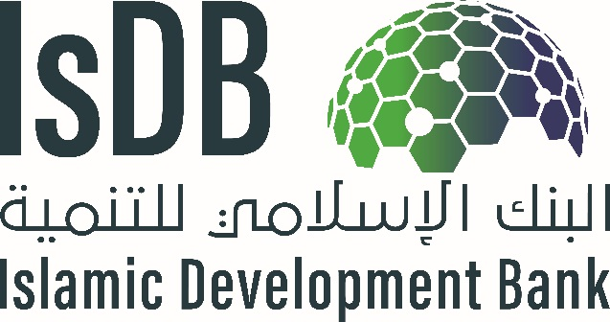

# Project Design Report Template

**PROJECT TITLE”**

**Project Number:** “Insert the Project Code”

**Country:** “Insert the Name of the Country”

**Department:** “Insert Department in charge of project”

**Acronyms and Abbreviations**

**Glossary**

**Currency and Measurement Conversions**

**Key Stakeholders and Focal Points**

|  |  |  |  |
| --- | --- | --- | --- |
| **Name** | **Designation** | **Contact No** | **Email** |
|  |  |  |  |
|  |  |  |  |
|  |  |  |  |
|  |  |  |  |
|  |  |  |  |
|  |  |  |  |
|  |  |  |  |
|  |  |  |  |
|  |  |  |  |
|  |  |  |  |

**[1]**

Date of Study:

Dates of Field Visits and Stakeholder Consultations:

**Name of the Project, Country**

1. **Strategic Context**

The annotation for this document is for guidance only, please remove it in the final document.

This section will include a narrative in the following sub-sections that will describe in summary the context and rationale for developing the project and seeking financing from IsDB:

**Brief Project History:**

1. Provide information relevant to the origins of the project, including the following:
   * Timeline towards conceptualization, development, preparation and appraisal of the project
   * Approval and endorsement of the project by different government authorities
   * Internal processes undertaken to clear/ endorse the project concept and feasibility study
   * Additional steps to be undertaken for clearance of the feasibility study by relevant country authorities and its inclusion in countries investment program for the year
   * Participatory approach used in preparing the project (consultations/ interactions with stakeholders and its outcomes)
   * Documents, studies, consultations and information on the basis of which the feasibility is prepared.

**Other Similar Projects Planned or Already Undertaken in the Country and their Performance:**

1. Provide a brief description of other similar projects undertaken in the country with specific reference to their current status, financing, and performance.

Suggested table as follows:

Country Sector

|  |  |  |  |  |
| --- | --- | --- | --- | --- |
| **Source of Funds** | **Project Name** | **Key Dates**   1. **Approval** 2. **Completion** | **Amount (US$ m eq.)** | **Status**  **Ongoing or Completed and other details** |
|  |  | a.  b. | a.  b. |  |
|  | a.  b. | a.  b. |  |
|  | a.  b. | a.  b. |  |
|  | a.  b. | a.  b. |  |
|  | a.  b. | a.  b. |  |
|  | a.  b. | a.  b. |  |

*Provide additional information in* ***Annex if needed.***

**Project Context:**

***Sector Context:***

1. Provide a brief description of sector context relevant to the project, including the following:
   * Description of the salient features of the sector in the country, and its potential/opportunities
   * Details of the sector situation and performance in the country, supported by recent statistics
   * Relevant sector policies of the country
   * Explanation of key sector issues/challenges/major constraints hindering the growth of the sector in the country that will be addressed as part of the proposed project
   * Possible solutions for addressing these constraints
   * Government strategy/ policies for development of the sector
   * Interventions by other Development Partners (DPs) helping to improve this sector in the country / address sector challenges.

*Provide additional information in* ***Annex if needed***.

***Thematic Context:***

1. Provide a brief description of the thematic context, including the following thematic considerations: include relevant information on women and youth empowerment strategies in the country in general, and the sector of the project in specific.

**Alignment with Government Strategy:**

1. Provide a brief description of the alignment of the project with the Government country and sector Strategy, covering the and how it will help achieve the SDGs. Provide specific linkages with SDG indicators and government policy pillars which the project will directly address.
2. **Project Development Objective and Rationale**

This section states the development objectives of the proposed project, including the key project results indicators and information related to target beneficiaries. The project objective should be outlined as:

1. Impact: Higher level contribution to government national strategy or sector strategy
2. Outcome: Specific objective the project will achieve directly after its completion and key indicators to measure that. The indicators should be “SMART” (see log-frame on relevant information required for each indicator)
3. Outputs: Key direct deliverables that will result through completion of project activities with SMART KPIs

Outline the direct beneficiaries in specific location and their socio-economic characteristics as well as indirect beneficiaries.

**Project Objectives:**

1. Include the project development objective (PDO) directly relevant to the issues being identified. While defining the PDO, the following are considered:
   * Problem Statement and problem tree: “What is the problem(s) the project is going to address?” This should be a critical constraint or a priority earlier mentioned in sector context. Presenting a problem tree is essential to show how the project (see project description) will address the sector constraint through project activities.
   * Linkage of Project Development Objective to Problem Statement and Country’s Development Goals / MCPS

NOTE: Project Development Objective is a clear, succinct and measurable objective statement.

Provide the project log-frame as below:

SMART and CREAM indicators are the following:

* *Specific* – stated clearly and relate to the results the project seeks to achieve.
* *Measurable* – can be monitored and provide verifiable data (quantitative)
* *Achievable* – are neither too ambitious nor too modest. The latter will call into question the planned investment.
* *Relevant* – useful for management information purposes.
* *Time-Bound*– stated with target dates.
* *Clear* – precise and unambiguous.
* *Relevant* – appropriate and timely.
* *Economic* – the data is available at reasonable cost.
* *Adequate* – sufficient to assess performance (in order to reduce the number of indicators for a given result).
* *Monitorable* – can be independently verified.

|  |  |  |  |  |  |
| --- | --- | --- | --- | --- | --- |
| Country and Project Title:  Project Purpose: | | | | | |
| Narrative Summary | Performance Indicators | | | Means of Verification | Assumptions |
| Indicator | Baseline | Target |
| Impact(s) |  |  |  |  | Sustainability assumptions |
| Outcome(s) |  |  |  |  | Country effectiveness assumptions |
| Outputs |  |  |  |  | Project effectiveness assumptions |
| **Key Activities**  Component 1:  Component 2:  Etc. | Inputs  Component 1:  Component 2: (etc.) | | |  | Project implementation assumptions |

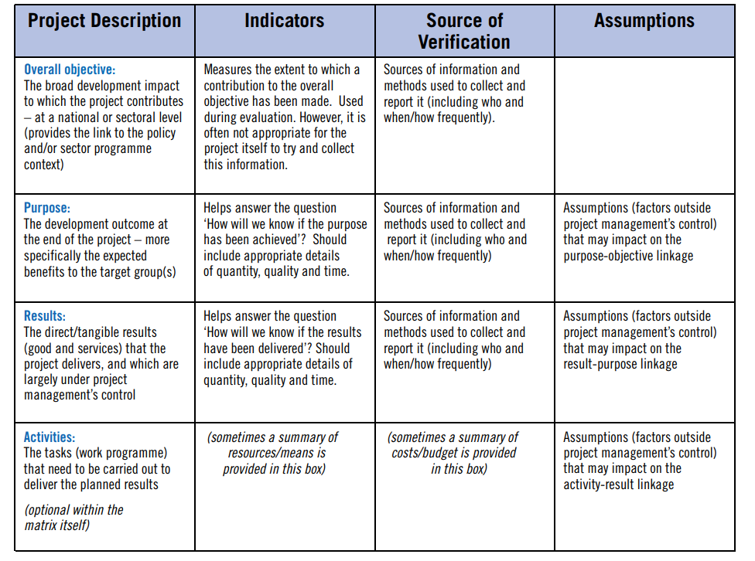

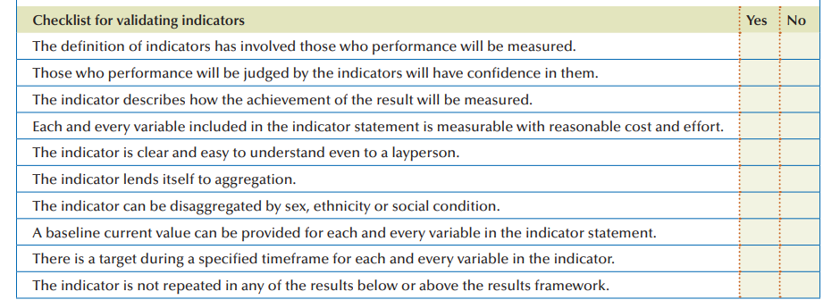

**Project Location:**

1. State the location of the project site (s), region/ provinces, highlighting the access to the project site, the overall commination mechanisms, i.e., access to road, rail, etc. and distances from the main cities/ airports. Any other socio-economic and logistical indicators relevant to project implementation. Also indicate if the land is available or steps to be undertaken to ensure project location is available to start the project with timelines.
2. Provide the **Project Location Map(s)**

*Provide additional information in* ***Annex if needed****.*

**Project Beneficiaries and Stakeholder Consultations:**

1. State the target beneficiaries (age and gender disaggregated), direct and indirect, of the project. Moreover, provide information about ownership by national stakeholders (govt ministries and other stakeholders) and beneficiary groups evidenced through consultations with key project stakeholders and participatory processes that were held during the design and preparation stages of the project. The consultation modalities should be briefly outlined for the various types of stakeholders involved. Key findings of the consultations, and concerns raised by beneficiary groups, especially women, youth and vulnerable groups of the population, should be presented. Further concerns of any stakeholders which may not support the project should also be noted. Lastly, the priorities or consultations with direct beneficiaries of the project, including private sector that will utilize project facilities should be outlined clearly. Provide stakeholder analysis table summary below:
2. Stakeholders Chart

|  |  |  |  |  |  |  |
| --- | --- | --- | --- | --- | --- | --- |
| Diagnostic Phase | | | | | Design Phase | |
| (1)  Stakeholder  Group | (2)  Interests | (3)  Problems Perceived | (4)  Resources/ | (5)  Mandates | (6)  Interest in the Project (proposed or underway) | (7)  Force-field Analysis |
|  |  |  |  |  |  |  |
|  |  |  |  |  |  |  |
|  |  |  |  |  |  |  |
|  |  |  |  |  |  |  |
|  |  |  |  |  |  |  |

**Rationale for Seeking IsDB Financing for Investing in the Project:**

1. State the rationale for proposed IsDB financing, including the following:
   * Rationale for Country and Sector Support: Key development country / sector issues addressed by the project. This should be linked to sector/ country context.
   * Alignment with country’s development strategy / priorities and sector-specific strategy and the basis for the project being a high priority for the country,
   * Alignment with policies/activities of the government and other DPs who are also working in the sector.
   * Alignment with SDGs
2. **Project Description**

This section includes a description of the core of the project, including the project’s scope, components, financing plan and reflects lessons learned within project design. This is the MOST important section of the feasibility study,

**Project Design and Scope/Components:**

1. Provide a brief description of what the project entails, including the proposed project design, different project components covering all categories of expenditures, i.e., Works, Goods and Services. It should include:
   * civil works
   * equipment
   * consultancies
   * training and capacity building
   * project management arrangements
   * audit arrangements
   * any other activities which are part of the project scope

It should cover detailed information on technical aspects of the project clearly indicating all activities which will be undertaken within the project scope to achieve the project results.

1. Provide the results tree linking project components with project objective. It will be directly linked with project problem tree presented earlier, to show how the project components will address some of the problems to achieve the project objective. A sample of project problem and results tree are presented below.

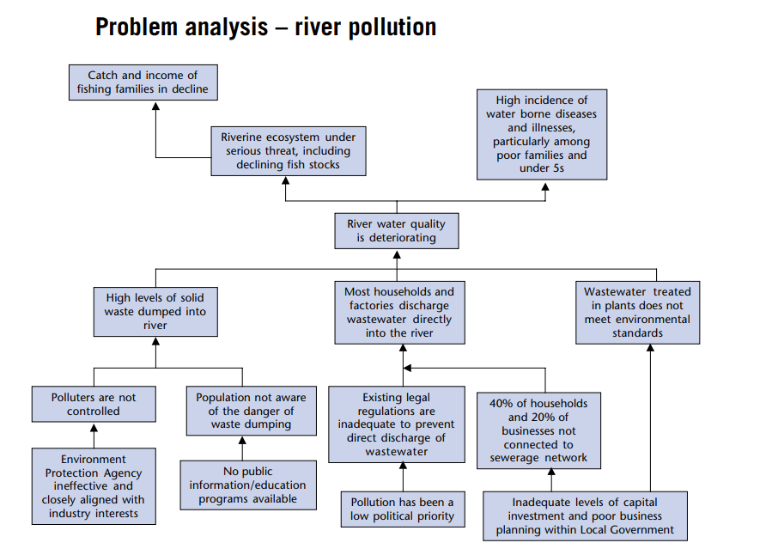

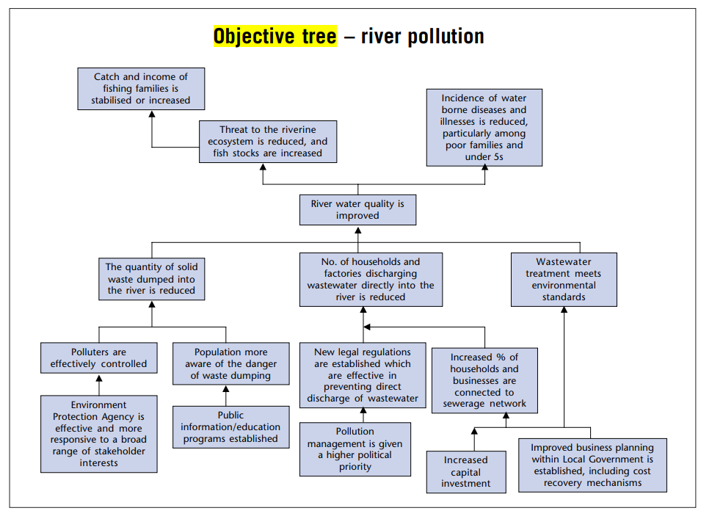

*Provide additional information in* ***Annex if needed***

**Past Lessons Learned and Reflected in Project Design:**

1. Provide a brief description of how the project design reflect on the lessons learned from on-going/completed projects by the country, and known best practices, including the following:

* Lessons learned from executing agency past projects, especially with other MDBs.
* implementation issues and current experience of Executing Agency in implementing such projects.
* Experience of implementing similar projects in other countries and lessons from those.
* Various remedial/mitigation measures proposed in the project to overcome issues faced during design and implementation of previous projects.
* Indicate in tabular form how each of the project lessons have been addressed in the project design.

1. **Project Thematic Orientation**

This section will include a discussion of the project’s orientation towards the Bank’s thematic areas.

**Climate Change:**

1. Provide a brief on integration of climate considerations in the project, including the following:

* Project Potential Contribution to Climate Adaptation, Mitigation, and Resilience
* Project Climate co-benefits
* Project Climate Finance share
* Project linkage to NDCs, NAPs, NAMAs or other climate relevant SDG goals
* Indicate clearly how the project design takes adverse climate implications into account and how the project contributes to climate adaptation, mitigation or building resilience as well as to countries climate and environment strategy. Also indicate how the negative climate impacts will be addressed during implementation.

**Women and Youth Empowerment:**

1. Provide a brief on the analysis on women and youth empowerment, fragility and employment generation (where applicable) and how that is integrated in the project design. Demonstrate how concerns raised by beneficiary groups, especially women and youth, are reflected in the design of the proposed project. This section should specifically indicate how the women and youth will be engaged in project implementation and benefit from its results. What is the project doing to ensure that these outcomes are achieved.
2. **Project Cost and Financing Plan**

This section includes the project cost and financing plan information.

**Project Costs:**

1. Provide an item-wise project cost estimate in detail in the table in local and foreign currency (US$ equivalent). Local currency items are those which are expenses that will be made in local currency, while foreign currency items are those which are imported to implement the project. This should not include any operational expenses and only expenses to be incurred to complete the project investment. Provide breakdown where necessary through additional tables for specific activities. BOQ and TOR based tables where applicable for specific activities should be separately provided in addition to overall project table.
2. Outline all key assumptions and sources used in calculation of costs

|  |  |  |  |  |  |
| --- | --- | --- | --- | --- | --- |
| **Sr. No.** | **Project Component** | **Category of Expenditure** | **Local Cost** | **Foreign Cost** | **Total Cost** |
|  |  |  |  |  |  |
|  |  |  |  |  |  |
|  |  |  |  |  |  |
|  |  |  |  |  |  |
|  | Base Cost |  |  |  |  |
|  | Contingency (Physical) |  |  |  |  |
|  | Contingency (Financial) |  |  |  |  |
|  | Total Cost |  |  |  |  |

Provide detailed cost and resource schedule. Template is below:

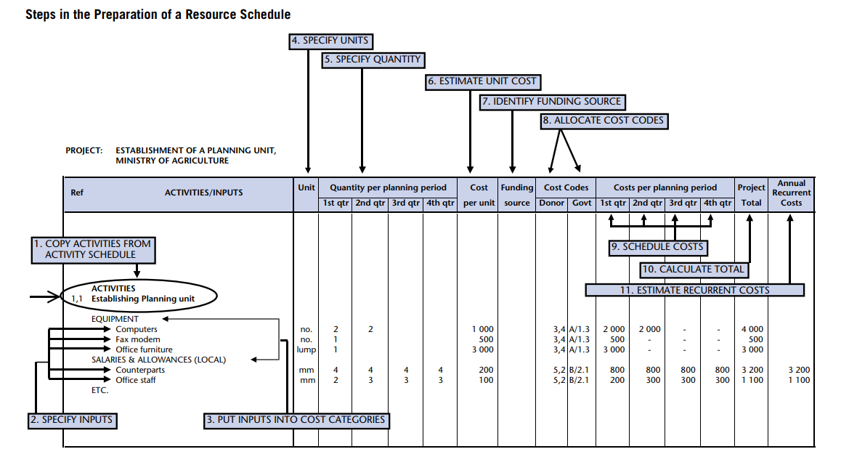

**Proposed Financing Plan:**

1. Provide the proposed project financing plan which shows the suitable mode of financing and the various sources of funds for each project component in project currency

*Provide additional information in* ***Annex if necessary****.*

|  |  |  |  |  |  |
| --- | --- | --- | --- | --- | --- |
| **Sr. No.** | **Project Component** | **IsDB** | **Co-Financiers** | **Government** | **Total Cost** |
|  |  |  |  |  |  |
|  |  |  |  |  |  |
|  |  |  |  |  |  |
|  |  |  |  |  |  |
|  | Base Cost |  |  |  |  |
|  | Contingency (Physical) |  |  |  |  |
|  | Contingency (Financial) |  |  |  |  |
|  | Total Cost |  |  |  |  |

1. **Implementation Arrangements**

This section includes a description of the project’s implementation arrangements. It should be clearly developed with sufficient detail.

**Executing Agency / Agencies (EAs):**

1. Provide a brief description of the suitability of the Executing Agency (main agency that will oversee the project implementation) / Agencies, including the following:

* Identification of the suitable EA and Implementing agency (if different from executing agency or if more agencies are involved or specific departments within the implementation agency)
* Listing the main Responsibilities / Functions of EA and IA, including the effect/ collaboration of other institutions/ ministries on these roles
* Project implementation capacity of EAs: Staffing of EA, prior experience of EA(s) of working on similar projects, same location/area, IsDB in particular and other MDBs and DFIs in general, and the brief on the status of those projects / programs;
* Assessment of agencies capacity, experience and skills to manage project implementation from a technical, financial and procurement standpoint, and adequate capacity-building measures (if needed) that are built in the design of the operation. The specific capacity building needed should be included in project components.
* Assessment of adequacy of operational rules, regulations, procedures and staff incentives that will enable the agency/ies to successfully implement and later operationalize the project.
* Assessment of financial management systems and capacity of the EA/ IA and their systems in the area of planning and budgeting, management and financial accounting, reporting, auditing, and internal controls for efficient project implementation and sustainability.

*Provide additional information in* ***Annex if needed****.*

**Institutional Arrangements:**

1. Provide a brief on the institutional arrangements (exact description of who will manage the project implementation and decision making roles on day to day basis) for project implementation and the required reporting structure, including the following:

* Overall governance and project management structure/ organizational chart for Project Implementation with all relevant stakeholders / institutions clearly identified and their roles/ responsibilities listed clearly. Organogram for project implementation setup
* Project Management Unit (PMU): Mention where the PMU is housed, including its main responsibilities, experience, reasons for selecting particular type of PMU structure, financing of PMU and Budget / capacity building needs of the PMU
* Structure of PMU: Staff composition of PMU and their roles, reporting structure, and coordination requirements
* Project Implementation Unit (if required): Mention location (s), staffing budget, and the TOR, etc.
* Project Implementation Consultant(s) if needed: provide the reasons and corresponding ToR
* Staffing of the Project Management / Implementation Unit and Implementation Consultants (if any) along with their intended TORs

*Provide additional information in* ***Annex if needed****.*

**Implementation Plan and Project Readiness:**

1. Provide a brief on the status of project readiness, including the following:

* Project implementation plan / chart by key project components: This indicates the estimated time / schedule / timeline for project implementation, kind of works that have already been completed or commenced, and key implementation milestones (key implementation dates). This should accompany a Gantt chant with clear activities in detail. Example of part of the gantt chart is below:

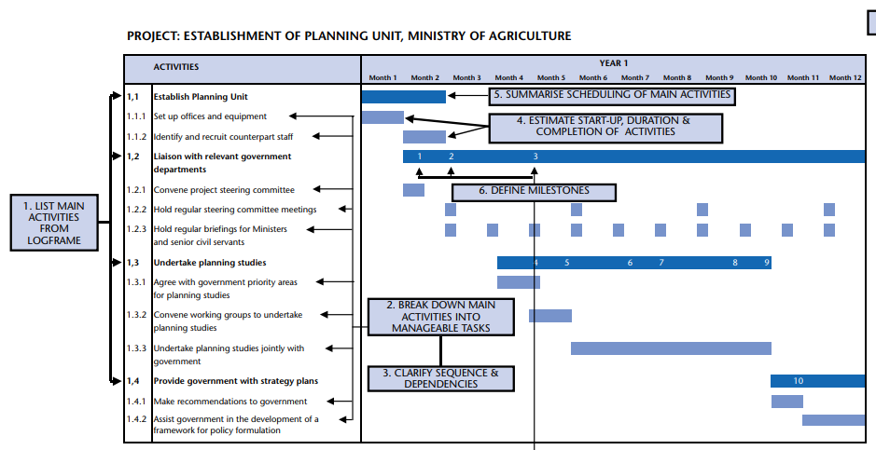

* Presentation of modalities for the participation of national stakeholders and beneficiary groups during implementation, including CSOs and beneficiary groups, who will be involved in the implementation of the proposed intervention and analyzing its results.
* Project Readiness: This can be indicated by answering the following questions:
  + What is the status of project design/bidding documents for the first-year implementation program?
  + What is the status of readiness of specifications or the timeline to do that and who will do it
  + What is the status of PMU, i.e. is it in-place and staffed? and timeline for that (should also be reflected in Gantt chart above
  + Are the required physical facilities – land, utilities etc. available?
  + Is Counterpart funding available?
  + is government approval obtained on FS or timeline to obtain that
* Measures, if any, to fast-track implementation (as part of implementation strategy)

*Provide additional information in* ***Annex if needed***

1. **Project Results and Monitoring**

This section includes a description of the project results and monitoring and evaluation (M&E) framework.

**Key Development Results Indicators:**

1. Include a summary of development results that the project will deliver in line with its objectives, with clearly defined cause-and-effect relationship all along the result chain, i.e., inputs, activities, outputs, outcomes and impact. The development results will include outputs, outcome(s) and impact with the associated SMART results indicators.

Provide *additional information in* ***Annex if needed****.*

**Monitoring and Evaluation of Outcomes/Results:**

1. Provide a brief description of project’s M&E framework, including the following:

* Monitoring and evaluation framework to track inputs, outputs and outcomes and evaluate the project results. The framework must be accompanied by SMART results indicators, with appropriate baseline and target values, and the corresponding sources of information for verifying them.
* Roles and responsibilities for monitoring results indicators during implementation
* Mechanisms used for Project Monitoring and Evaluation: it will include a summary of the mechanism agreed with the PMU/PIU to submit to IsDB the status of implementation, achievement on outputs and outcomes indicators and actions taken to ensure satisfactory project implementation.

**Project Monitoring and Implementation Supervision Plan:**

1. Provide a brief overview of the mechanisms for project’s progress monitoring and progress reporting, including the following:

* Provide a project results monitoring plan covering key objective, KPIs, source of information, frequency of information collection, responsible party to collect the information, cost of information collection, storage and compiling of information, MIS to be used etc.
* Arrangements for coordination and exchange of information amongst the key stakeholders (government, implementing entities, consultants, contractors, IsDB and the co-financiers, if any), with responsibilities clearly assigned
* Assessment of the capacities of the execution and implementing agencies to fulfill IsDB’s information needs and reporting requirements, related to reporting on project implementation, KPIs, procurement, financial management and risks
* Information on the agreed Project achievements (including key milestone dates, PIASR frequency, trigger for the Mid Term Review)
* M&E reporting requirements.
* Type of activities, tools and mechanisms used for supervising, monitoring and reporting progress:
  + Reports submitted by EA / PMU to IsDB: Frequency / schedule of submission, contents of the report outlining project progress achievements, financial progress, procurement plan progress, problems encountered, and mitigation actions
  + Project Start-Up Workshop: Purpose and scope, location
  + Project Supervision Missions by Senior EA staff
  + Mid-term review: agreement on the milestone to launch the review to assess the overall performance of the Project and gap analysis to identify if any improvements are needed

*Provide additional information in* ***Annex if needed****.*

1. **Project Risks and Sustainability**

This section includes description of the project risks and project sustainability.

**Project Risks:**

1. Provide a brief description of the potential risks associated with the project, the impact of the risk proportional to its severity, likelihood of the identified potential risks, and the proposed / existing mitigation measures including responsible party to manage it during implementation and upon completion, including the following:

* The Project Risk Matrix: Identify all the potential risks associated with the project (with specific emphasis on project sustainability), assess and assign a risk rating to each risk, and provide an explanation for the risk rating considering the severity/ impact of risk, likelihood of the risk. This will identify the overall risk rating of the project. **The risks should be assessed both from the lens of these factors impact on project as well as how the project itself increases these risks.**  The risks can either be things that can “go wrong” in the project compared to plan during implementation and operations or “any outcome worse then what was targeted in the results matrix”. Ideally, the impact of most severe risks should be quantified, while others can be qualitatively assessed. The risks are identified related to the following categories
  + Stakeholder Risks: This includes risks related to Counterpart, Co-financiers, Beneficiary, Contractors/Suppliers
  + Country Risks: This includes risks related to Political/Security, Economy and Legal Risks.
    - *Economic risks: how will macroeconomic situation impact the project during implementation and operations. What macroeconomic assumptions are made and why? How can the impact of economic growth, inflation, tax or subsidies, government policies be made favorable to increase project success? Can the impact of these risks be reduced?*
    - *Economic Resilience: Vulnerability of project to world events; impact of project on increasing economic vulnerability.*
    - *Site availability and permits from various agencies*
    - *Political Risks: This includes continued support from beneficiary/ government for project; change in government or key ministries or its structure; change in operating laws or regulations; war/ unrest; nationalization risk for potential beneficiaries which may invest after project completion; FOREX and capital flows laws; currency controls and exchange rate controls.*
    - *Legal and Policy Risks: Change in statute- taxes, environmental laws, employment laws, investment laws, H&S standards, change in strategy or sector policy etc that impact project during implementation and operations.*
    - *Pandemics that could impact pace of work.*
  + Economic and Financial Risks: This includes assessment of the following:
    - *Demand risk: how much demand is present for project goods/ services. Is the market growing or shrinking; what are local, regional and global trends? What are the alternative markets available. What alternate products can be produced if market for one product shrinks? What is the possibility or available off-taker agreements? What marketing strategies and consumer segmentation strategies can be used (different regional markets or different product categorization for example?)? What subsidies will be provided and what cost they will entail to government?*
    - *Price Risk: Are prices for products or services offered by project reasonable? How much can market price vary for inputs and outputs? How volatile are the prices? can the prices be locked or long-term agreements to secure prices available in any market? how much market power would project have in determining prices? Is there a govt set price? Are there subsidies available or required and how do they distort the market? Are prices determined locally or internationally? What is the ability to pass through inflation through high prices?*
    - *Product Differentiation/ Competition: Is the service or product different from what is available in the market. Is the market competitive. Who gets the margins and how can they be maximized for targeted beneficiaries. Is the product solely provided by the project or government or other entity. What risks or benefits that entails? How will the product market change, competitors react or impact on behaviour of other providers of same products and services? Does the project “crowd-out” private suppliers market? Are their markets for “special” products such as organic production? Is country member of such agreements which offer access to these markets?*
    - *Counter party or consumer risks: Can consumers pay for the product/ service. Do they have capacity or credit worthiness? Are their guarantees (such as govt guarantees) available that minimize the risk? What mechanisms are available if counter party defaults?*
    - *Exchange rate risk: Is exchange rate risk significant. Is foreign currency available for operations? Will the counterparty be able to secure finance from market to buy the offered product and service?*
    - *Resourcing Risks: Can the required materials, labor and other inputs to project during investment and operation be obtained at reasonable cost and time.*
    - *Financing Risk: is there a gap in project financing. What are the risks to obtaining the financing at reasonable rate and what alternates are available for cheaper financing? How will co-financiers engagement increase or change project risks and returns?*
    - *Volatility: how volatile the project cash flows are and what mitigation are available?*
  + Social Risks: This includes assessment of the following risks:
    - *Environmental risks: the risks related to environmental hazards, environmental degradation, etc*
    - *Health risks: related to possible negative health impacts to project direct and in direct stakeholders.*
    - *Social unrest: such as widening social divides or possibility of creating conflict among different stakeholders.*
  + **Project Risks:** This includes risks related to Design, Operations, Accessibility, Sustainability/Results, and Project Procurement Risk
    - Operational risks, including:
      * *Capex Risk:* *capital expenditure risk (or cost overrun)- what if it costs more then estimated and what has been done to mitigate this. What will be done if there is cost overrun?*
      * *Design risk: will the project deliver the intended results/ will it produce the required outputs? Will it work as per expected standards of operations (capacity and quality)? Will the outputs lead to desired outcomes? Will the desired design be delivered?*
      * *Processing Risk: will the technology or any production process in the project be able to process inputs/ raw materials as envisaged? Is it robust? Can raw material/ input be varied and still lead to same results? How much do we need to control the inputs quality to achieve intended production results? Are their by-product markets or can services be provided for other purposes then intended?*
      * *Construction risk, related to risks of contractors to deliver the assets on time. Availability of service providers and their capacity.*
      * *Technological risk: Will the technology used work in the project context as intended? Do we have guarantees? Are their test runs or defect liability period? Who holds this risk.*
      * *Obsolescence risk: will the technology become obsolete before the intended project life? How can we leave possibilities for upgrades? How much investment is worth putting. How would new technology impact the project?*
      * *Volume risk: will the project solution(s) be able to deliver if scale changes? What would be the costs of such scale changes? How can we improve sustainability at low volumes? Can volume be scaled up or down quickly?*
      * *Input risks: Are relevant inputs available for delivery and operations of project. What happens if their price changes. Do we have supply guarantees?*
      * *Timing Risk: Delay in achievement of various milestones and overall completion and operational timelines.*
      * *Operations and maintenance risks including: (i) available capacity locally, (ii) available markets; (iii) costs and funding source; (iv) any subsidies available? (v) management structures?*
      * *Site risks: such as suitability of site for intended project activities. Initial assumptions about site don’t hold true.*
      * *Labor risk, such as non-availability of skills or labor strikes and wage disputes during implementation or operation.*
  + Executing/ Implementing Agency Risks: This includes risks related to Capacity, and Fiduciary Risks
    - *Adherence to IsDB procedures*
    - *Capacity of EA to implement the project on time.*
    - *Financial mis management.*
* Defining Risk Mitigation Measures with clear Responsibility for each risks in the Risk Matrix: Determine appropriate response strategies and actions for each individual risk
* Risk Management Plan: Highlight the plan and mechanism to monitor the identified high impact risks during implementation of the project for overall project risk mitigation

*Provide Risk Matrix as below:*

|  |  |  |  |  |  |  |  |
| --- | --- | --- | --- | --- | --- | --- | --- |
| Risk Category | Risk | Risk Impact Level | Likelihood | Mitigation Measure | Risk Impact after Mitigation | Responbile to manage | Risk management strategy |
|  |  |  |  |  |  |  |  |
|  |  |  |  |  |  |  |  |
|  |  |  |  |  |  |  |  |
|  |  |  |  |  |  |  |  |
|  |  |  |  |  |  |  |  |
|  |  |  |  |  |  |  |  |

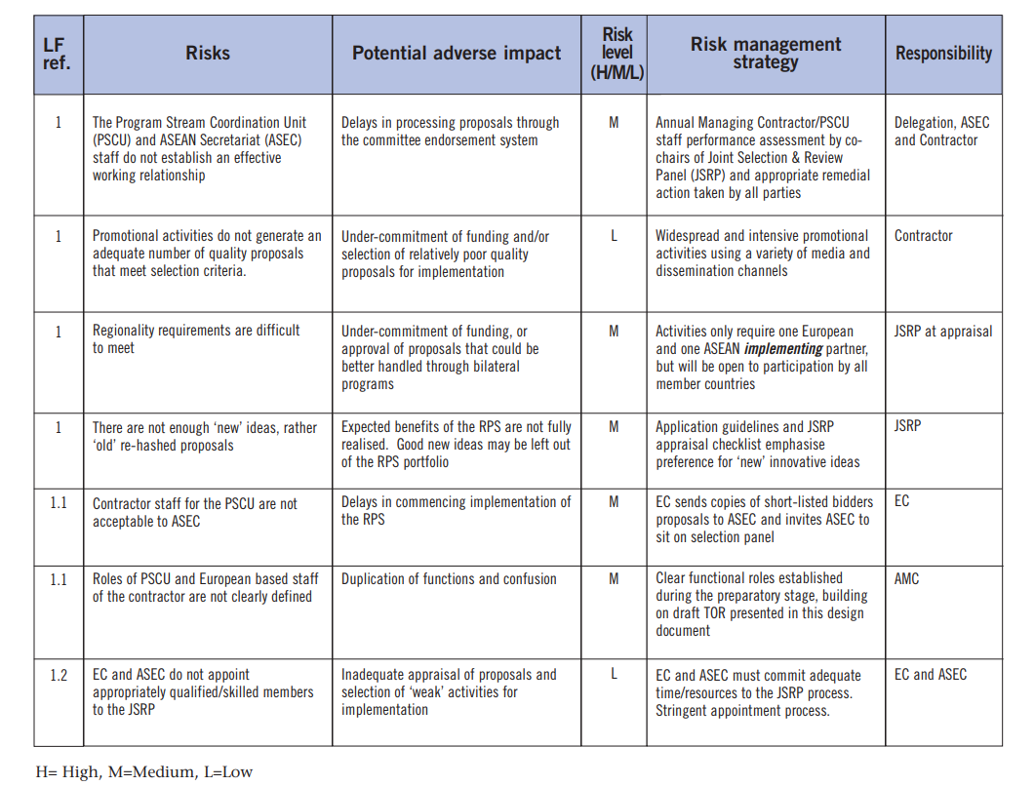*.*

**Project Sustainability:**

1. Taking into account the various risks and mitigation measures identified in the Project Risk Matrix, provide a general summary of the effectiveness of the measures to ensure sustainability of the proposed intervention with respect to the following dimensions:

* **Economic Sustainability:** It addresses the economic effectiveness and expected economic impacts of this project over its life cycle. It should assess the impact of the project on economy and sector as well as associated costs to economy. Economic sustainability also entails potential wider economic benefits that may not be captured through the EIRR and how they will lead to sustainability of project results.
  + **Social Sustainability:** It describes how the project would impact the poor, vulnerable groups and some target groups such as youth, women, and how the project would strengthen social cohesion and enhance social inclusiveness. It also entails any impacts that the project may have on the safety and security of the people in addition to any other socio-economic impacts it may have (such as new employment opportunities). It should demonstrate the positive and negative impacts of the project on social structure and whether that would lea to continuation of project benefits or risk its sustainability. Conduct distribution analysis covering: (i) Which group benefits and loses. ; (ii) Is it in line with the targeting. (iii) What kind of incentives and disincentives are created as a result of this and is it assessed in the risk and assumption analysis.
* **Environmental Sustainability:** It describes the entire life cycle of the project (construction, maintenance, and operation) and its impact in each of these stages on the surrounding environment as reflected by the Environmental and Social Impact Assessment (ESIA). It also takes implementation of the Environmental and Social Management Plan (ESMP) into account. In addition, resilience of the project to the long-term risks from climate change (climate change resilience) may also be highlighted in this section.
* **Operational Sustainability:** It is a cross-cutting criterion that addresses some of the main weaknesses usually found in projects, namely: i) Operation and Maintenance (including setup and budget availability); ii) Institutional Capacity, and Regulatory Framework and government support; iii) Resilience of the project results and Implementation to exogenous factors (i.e., resilience to risks).

1. Particular importance is to be made on the mechanisms agreed that allow local stakeholders to provide feedback and to monitor implementation of such mechanisms.
2. **Project Feasibility**

This section assesses the feasibility of the various aspects of project

**Technical and Operational Feasibility:**

1. Provide an assessment of the technical and operational feasibility of the project, outlining how the project achieves to answer the following questions. **This not a YES or NO answer but should be detailed assessment substantiated by relevant evidence and information. This needs to be very detailed to allow IsDB to assess the project feasibility independently:**

* Will the technical solution/ design of overall project proposed address the key problem being addressed and development objective being achieved?
* How does project address the sector binding constraints (regulatory, infra or policy related).
* What is the performance of the Public entity providing services, its management and government finances for the sector and entity.
* How does the project contribute to demand, affect cost, promote technology.
* What are the new investments expected in sector and how will they impact project.
* Is project the best way to address the issue.
* What are the government interventions (taxes, subisidies, price controls etc) that support or hinder the project results.
* Demand – supply analysis of the sector and other sources of supply.
* What is the Government sector development plan and how will it impact the project deliverables.
* How well proven the proposed design solution is in other projects/ countries.
* What technology is proposed and what pros and cons it has. Has it been tested elsewhere?
* What are the assumptions within which the proposed solution will operate? How well can it operate if assumptions don’t realize?
* How well can the technology operate in different circumstances.
* What is the capacity available locally or internationally to implement the proposed solution.
* What kind of operational expenses, equipment, other resources will be needed in implementation and during operations? Are they available? Who are the suppliers for these items/ resources/ technologies.
* What potential operational and managerial problems can be experienced in managing the provided assets as well as any key technology and equipment?
* How robust is the proposed solution to meet the demand of beneficiaries.
* How long and what key items would need to be replaced?
* Can the project be done within the planned cost and time and other resources?
* Is the technology adequate?
* ▪Upon completion, is the project capable of operating as planned?
* Does the country poses capacity (management, manpower etc) to implement and operate the project?
* Can the project sustain for its planned lifetime?
* Are implementation arrangements adequate to implement the project?
* Are post-project implementation mechanisms for operation adequate?
* How will the supervision consultants be engaged?
* What capacity building aspects have been included for successful implementation?
* Are operational risks, such as capital expenditure risk, design risks, processing risks, technology risks, obsolescence risks, volume risks, and input supply risks and their mitigation adequate? Assess the overall operational and technical risk.
* What other alternate design and technology alternates are available and why were they not considered?

**Economic and Financial Analysis and Feasibility:**

***Alternative Solutions:***  This section should outline key alternative solutions which have been rejected in favor of project design. The alternative solutions could entail different options in following areas:

* With or without project
* scale of project
* beneficiaries
* type of outputs/ services
* technology
* location
* starting date
* sequencing of components
* Implementation arrangement

***Financial Analysis and Feasibility:***

1. This section should provide the detailed description of the project’s financial analysis undertaken to determine its financial viability when compared to alternative project options. Provide the financial analysis of the project that answers the question, ‘Is the financial rate of return acceptable?’ Additionally, mention the key assumptions underlying the financial analysis, including the key risk factors based on the results of sensitivity analysis.
2. The financial analysis should take into account the various financial costs and benefits (at market prices), as follows:

* Revenues
* Operating Costs
* Capital Costs
* Working Capital

1. The financial analysis and feasibility should look at factors such as:
   * total production or marketable output/ services generated by the project, the amount/ volume of that output/ services
   * size and nature of the market where these outputs/ services will be sold. Who are the target consumers/ off-takers and what determines their demand; what is their socio-economic situation.
   * Demand for project services and price curve
   * Total demand and share taken by project
   * Impact of project on prices and tariffs.
   * Future growth trends of the market and what can terminate the demand. What are the competitive, social or political advantages that project produced services/ output has over alternates?
   * Impact of local and global macroeconomic situation on project finances and cash flows (both inputs and outputs), including economic growth, inflation, exchange rate, taxes and subsidies, trade regimes, labor laws etc.
   * Factors impacting the demand for the product in short term and over the project period
   * Price at which the products can be sold
   * Recent and long-term trends in pricing and what can impact that, both locally and globally depending on the projects products/ services.
   * Costs at which inputs are available and what are their cost determinants.
   * What are the prevailing price distortions and sources of distortions: Taxes/ price controls/ imperfect market.
   * Exchange rate movements and trends that could impact the project costs and prices
   * Possibility and nature of any “off-taker” agreements
   * Ability of consumers (or those paying on their behalf) to pay
   * cost for production/ investment over the project lifetime
   * Factors that impact the inputs availability and cost
   * CAPEX and OPEX costs determinants
   * Assessment of all financial and economic risks as stated in the risk section.
   * What guarantees, warranties and other securities are available that impact risks to cash flow.
   * Project reliance on FOREX and mechanism of its availability during investment and operations stages
   * If other co-financiers are involved, can the project be financed at reasonable rates. What alternate financing channels are available? Is the chosen financing best and most practical among various options available?
   * Is the FIRR of project comparable to other such projects locally or internationally?
2. Additionally, all the assumptions underlying the financial analysis must be clearly stated with appropriate reasoning.
3. The following financial indicators of the project should be used to determine the financial viability of the project:
4. Net Present Value (NPV)
5. Financial Internal Rate of Return (FIRR)
6. **Describe the results of project sensitivity analysis and identify the key risk factors that will have the maximum impact on the financial returns of the project. Key severe risks identified in the project risk matrix should be analyzed using sensitivity analysis to determine their impact on project FIRR as well as benefits.**

***Economic and Social Analysis and Feasibility (Separate Social Feasibility should be done when project is of “Social Nature”):***

1. This section should provide the detailed description of the project’s economic analysis undertaken to determine its economic viability when compared to alternative project options.
2. Provide the economic analysis of the project that answers the question, ‘Is the benefit/cost ratio for the country acceptable? and what Economic and developmental benefits are generated from the project, which may not be measurable. It covers the impact of the project on wider society and economy. It should incorporate benefits that associate to wider shareholders beyond the direct stakeholders such as project lenders, operators, and employees/ labor engaged. The economic feasibility should assess the project impact on:
   * Broad employment outcomes and multiplier effect of the project
   * Health outcomes
   * Educational and improved capacity outcomes
   * Growth of economy
   * Poverty reduction
   * Women empowerment
   * Improved governmental services.
   * environmental benefits
   * Additional tax revenue
   * Economic resilience and diversification
   * Increased forex or exports

It should also evaluate and analyze any negative impacts of the project and how they have been mitigated in project design, including:

* + Environmental degradation, hazards, habitat destruction
  + negative health outcomes such as accidents, health hazards during construction or operations for labor or community
  + impact of traditional lifestyle, culture or local population
  + Economic vulnerability such as making the economy more vulnerable to world economy downturn or global pandemics
  + Negative impact on balance of payments
  + Increased inequality
  + Increased vulnerability to any disasters or natural risks
  + Increasing social tensions among various groups

To the extent possible, the feasibility should quantitatively measure the project economic impacts quantitatively using best assumptions and expected impacts on these indicators. The details of environmental, social, gender and resilience should be thoroughly captured in relevant sections of the Feasibility Report. The summary of that assessment can be presented here.

1. This should yield cost-benefit ratio for the project by incorporating all costs and benefits of the project. **The cost-benefit analysis should be done for with and without project scenarios:**
2. Economic analysis also reflects the efficiency in which a project’s economic resources are used to deliver its outcomes, which is primarily measured by the economic internal rate of return (EIRR) of the project. This entails assessing alternate ways of resolving the problem. Additionally, mention the key assumptions and parameters used in the economic analysis.
3. The alternative analysis should be provided covering:
   * Is the project most efficient way of addressing the issue.
   * What other alternates are available and at what unit cost of output?
   * Is there a quality difference between outputs of different alternatives.
4. The economic analysis should take into account the various economic costs and benefits (valued in terms of shadow prices), as follows:

* Revenues
* Operating Costs
* Capital Costs
* Working Capital

1. Additionally, all the assumptions underlying the economic analysis must be clearly stated with appropriate reasoning.
2. The following financial indicators of the project should be used to determine the economic viability of the project in comparison to alternates (EIRR of other alternate should also be ideally calculated):
3. Economic Net Present Value (NPV)
4. Economic Internal Rate of Return (EIRR)

1.