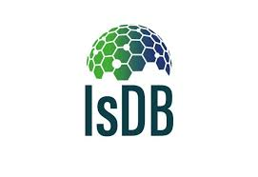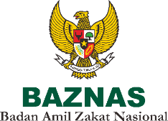

**BADAN AMIL ZAKAT NASIONAL**

Term of Reference

**Technical Training**

**for Community Engagement and Familiarization**

**COMPONENT 2: CAPACITY DEVELOPMENT**

**TECHNICAL ASSISTANCE FOR INTEGRATING ZAKAT AND COMMUNITY-BASED POVERTY REDUCTION PROGRAMS**

**Technical Training**

**for Community Engagement and Familiarization**

**Term of Reference (ToR)**

May, 2021

**Table of Contents**

List of Acronyms 4

1. BACKGROUND 5

1.1 Reference 5

1.2 Brief Description 6

2. SCOPE OF SERVICES 9

2.1 Objectives 9

2.2 Scope of Work 10

3. QUALIFICATIONS AND SELECTION CRITERIA 11

3.1 Firm Qualifications 11

3.2 Team Qualifications 12

4. DELIVERABLES 12

5. DURATION 13

## List of Acronyms

|  |  |
| --- | --- |
| **Acronym** | **Meaning** |
| BAZNAS | Badan Amil Zakat Nasional |
| CDD | Community Driven Development |
| EO | Event Organizer |
| ICDD | Integrated Community Driven Development |
| IsDB | Islamic Development Bank |
| ISFD | Islamic Solidarity Fund for Development |
| IT | Information Technology |
| NSUP | National Slum Upgrading Project |
| PMU | Project Management Unit |
| SDGs | Sustainable Development Goals |
| SOP | Standard Operating Procedure |
| TA | Technical Assistance |
| ToR | Term of Reference |
| VCC | Village Community Committees |
| WBS | Work Breakdown Structure |
| ZCD | Zakat Community Development |
| ZIS | Zakat, Infaq, and Shodaqoh |

# BACKGROUND

## Reference

Laws and Regulations related to this project are as follows:

1. Law No. 23/2011 on Zakat Management (Undang-Undang Nomor 23 Tahun 2011 tentang Pengelolaan Zakat)
2. Government Regulation of Republic of Indonesia No. 23/2011 on Implementation of Law No. 23/2011 regarding Zakat Management (Peraturan Pemerintah Nomor 14 Tahun 2014 tentang Pelaksanaan Undang-Undang Nomor 23 Tahun 2011 tentang Pengelolaan Zakat)
3. Presidential Decree No. 8/2001 on National Board of Zakat (Keputusan Presiden Republik Indonesia Nomor 8 Tahun 2001 tentang Badan Amil Zakat Nasional)
4. Technical Assistance Grant Agreement Between The National Board of Zakat (BAZNAS) and Islamic Development Bank concerning The Technocal Assistance for Integrating Zakat and Community-Based Poverty Reduction Programs
5. Technical Assistance Grant Agreement Between The National Board of Zakat (BAZNAS) and Islamic Development Bank (In Its Capacity as The Administrator of The Islamic Solidarity Fund for Development) concerning The Technical Assistance for Integrating Zakat and Community-Based Poverty Reduction Programs
6. Report and Recommendation of The Director General (Global Practices) to The Vice President (Country Programs) on Financing of a Technical Assistance (TA) Grant for Integrating Zakat and Community Driven Development Programs, Indonesia
7. Standard Bid Evaluation Form, Islamic Development Bank

## Brief Description

BAZNAS is an official institution and the only institution established by the Indonesian Government through Presidential Decree No. 8 Year 2001 which has the responsibility and functions to manage zakat funds and other Islamic religious charity (ZIS) at the national level. With the presence of Law Number 23 Year 2011 regarding Zakat Management further enforced the role of BAZNAS as an authorized institution to manage zakat at the national scale as an effort to eradicate poverty and increase the quality of human life.

Zakat, which is one of the five pillars of Islam and which is levied on all persons who have wealth above the Nisab (i.e. minimum eligible amount), may provide a sustained, self-replenishing source of financing for the uplifting of eight categories of needy. If this source of Islamic social finance is channeled in a coordinated matter for collective development of the needy (and eligible) communities, then Zakat could be an effective and sustainable tool for lifting the poor communities out of poverty.

The IsDB and ISFD, in collaboration with the BAZNAS in Indonesia, are piloting a project to improve the collection and utilization of Zakat resources to support some Community Driven Development (CDD) programs. The aim is to identify a model to improve the collection of Islamic Social Funds, such as Zakat, and effectively channel and maintain a sustainable flow of funds to support successful community-based poverty reduction programs, such as the National Slum Upgrading Project (NSUP) and Zakat Community Development (ZCD).

The subject project to integrate Zakat and CDD is a Pilot initiative, supported by IsDB and ISFD, and designed to provide capacity building of institutions and systems in order to increase the collection of Zakat and its distribution as grant funding in an effective and transparent way for community development. This is the first effort designed to develop effective mechanisms for the linking of Zakat and CDD poverty reduction programs. The intention is to validate the approach as a pilot in a limited geographical area and, assuming its success, go to scale nationally.

One of the project's component is a Capacity Development for stakeholders related to integrating zakat and community-based poverty reduction programs. This component will also support the development of a robust monitoring, governance and results reporting structure for BAZNAS, with a strong link to the use of Zakat for the achievement of the SDGs. Partnership with the UNDP may be sought in this regard, along with leveraging on the existing work and activities already undertaken to link Zakat and the work on achieving SDGs.

Community Driven Development (CDD) is essentially "*an approach that gives control over planning decisions, implementation and investment resources to community groups and local governments*". This forms an antithesis to the expert driven development which exclude the people in their own development. Local community groups and local government engage together in the entire development process, and share accountability in a transparent manner. The communities are provided with the required facilitation, training, skills and financing, and are given access to information for further learning and development.

The CDD Project Lifecycle, which can have variations depending on specific contexts, in general has the path described below, which is also schematically presented in Figure 1.

Note: Monitoring and Evaluation is a continuous activities throughout the lifecycle

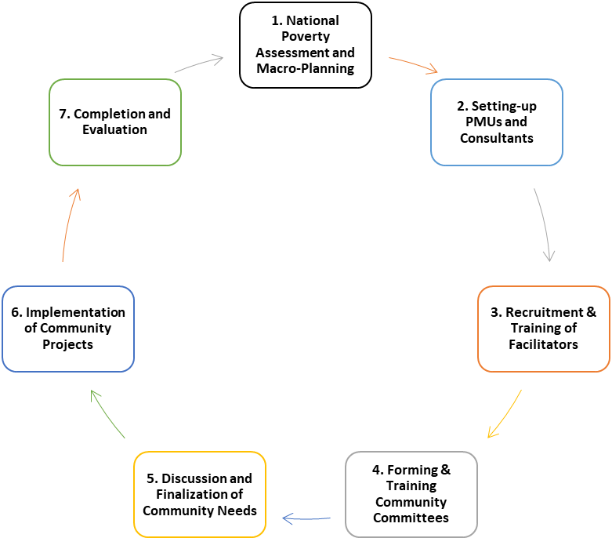

**Figure 1 ICDD Project lifecycle**

The following is an explanation of each stage of the CDD lifecycle:

* 1. The cycle begins with the selection of target communities, based on national poverty data and macro-planning by the relevant government planning bodies, processing and finalizations of the project.
  2. Following this, the relevant line ministry (e.g. Ministry of Public Works / Rural Development) will set-up Project Management Units (PMUs) at the different administrative levels and recruit the necessary consultants.
  3. Thirdly, the key players in the entire project, the facilitators, who constitute one of the most essential ingredients of the project and form the front-line in the development process, are recruited from among the communities and trained in community empowerment and facilitation skills to become 'Master Trainers' who will in turn train the communities. This is aimed at cascading the capacity development so that it has a multiplier effect and enables the program to build the critical mass required for effective community-based empowerment and development.
  4. The facilitators then assist to mobilize the communities to form Village Community Committees (VCCs) who will be trained to drive the project at the grass-roots level.
  5. These VCCs will then hold discussions, through a participatory approach, to identify and create a Medium Term Poverty Reduction Plan (MTPRP) for the village and then list and prioritize the development needs of each village. This a, called the ‘open menu’ typically contains a mix of infrastructure, social and economic activities. As the amount of funds available under the project is generally not too large (especially the allocation for each village), the communities will only be able to undertake small-scale Infrastructure Activities, such as building small access roads, tertiary irrigation networks, community water points, communal latrines, waste disposal units, renovation of schools, health centres, etc. For the Social Interventions, the focus may be on provision of cash to the dependent/vulnerable segments of the community (e.g. elderly, disabled, aged widows), scholarships for orphans, cash for health care to the dependent, etc. Economic/livelihood Activities will mainly consist of revolving funds (micro-finance) combined with vocational training.
  6. Once the 'open menu' is finalized and approved, each village is given a fixed amount of funds (i.e. the Block Finance) to implement these projects at the community level. The facilitators will work more actively with the community groups (Self-Help Groups, SHGs) , in addition to the VCC to ensure that there is sustainability and pro-poor targeting. This is a dialectic approach, where one the one hand, the communities as a whole are involved in social-oriented activities - called the ‘holistic approach’, while on the other, focus is also placed on building groups (SHGs) having poorer members – called the ‘targeted approach’. The strategy is to maintain the power balance, and share resources collectively while also investing in the capacity development of the poorer elements, hence the term ‘targeted within the holistic’ approach. This is seen to neutralize the power conflict, which generally arises in purely targeted approaches.
  7. The final step of the lifecycle is the completion of all the village projects followed by a thorough evaluation of the whole ICDD program. The results of, and lessons from, the evaluation of the ICDD project will provide feedback to the Macro-level Planning by the Coordinating Ministry to enhance the next cycle of community empowerment programs.

BAZNAS will undertake the work through its provincial and regency implementation teams: staff them up, develop standardized work programs, policies and procedures for Zakat mobilization, collection, local distribution and interaction with CDD and other programs, create manuals, and provide intensive organizational training for all staff. It will need to facilitate the setting of objectives and review of local team performance against these agreed upon programs and results. A decentralized resource mobilization methodology will be designed in the context of the new platform, staff trained in its use, and it will be made operational in all selected locations, so that the local units of BAZNAS will be able to raise and distribute Zakat locally to the NSUP and ZCD programs while managing transactions on the enhanced IT system.

In the linkage with CDD programs, the local teams need to be familiar with the mechanism of community planning, learn to work with communities to identify Mustahiq, as well as to assess and finalize Zakat-eligible activities (incl. costing). Subsequently, training would need to be provided to the teams on data collection, monitoring and reporting functions. Furthermore, the BAZNAS will also benefit from the experience in CDD and community engagement by the project management teams of the NSUP, through knowledge and content sharing activities.

# SCOPE OF SERVICES

## Objectives

The objective of this consultancy is to design and implement a capacity development program for Integrating Zakat and Community-Based Poverty Reduction Programs. The selected vendor shall be tasked to achieve the following objectives:

1. Technical Training for Community Engagement and Familiarization
   1. Design the course content and methodology
   2. Develop training materials
   3. Organize training delivery
2. Preparation of Manuals/Templates for Reporting
   1. Develop monitoring & evaluation framework for capacity development
   2. Develop manual/template for activity reporting
   3. Develop standard operating procedure (SOP) for knowledge management system

## Scope of Work

The program should include a comprehensive course that will provide an opportunity for the participants to learn from selected cases and receive technical knowledge. The course should strongly rely on case studies and concrete examples of community-based development experiences, including practical recommendations for its implementation, potential barriers and how to overcome them. This shall be done in a setting that allows exchange of experiences and dialogue and allows for a field visit if necessary. The capacity building program should also encourage the establishment of a community-of-learners among the beneficiaries, for continuous exchange of future experiences and offering them tools to become trainers of peers in their own communities and within their projects.

The participants, once they have taken the course, should:

* Understand the key elements involving community-based development;
* Be able to apply tools for planning community-driven development activities;
* Understand key elements to promote community management and organizational strengthening for the community-based development;
* Understand social participation issues, including gender, governance models, and other social issues.

Building on the objective outlined above, the consultancy firm will take a phased approach as follows:

1. Phase 1: Planning phase for the course
   1. Technical planning – contents of the course, methodology for the course and the establishment of the community of learners (the contents of the course shall be subject to modifications once the participants have been identified and their level of knowledge about the topic is assessed)
   2. Logistical planning – characterization and selection of the participants (in coordination with the PMU), arrangements (travel, lodging, course room and materials, meals, for trainers and participants)
   3. Design of course materials
2. Phase 2: Operational phase where the course will be implemented and the community-of-learners set up
   1. Implementation of the training course, including field visit if necessary
   2. During the event, gathering of photographs, videos and interviews
   3. At the end of the course, submission of a survey to measure satisfaction among the participants
   4. Establishment of the community-of-learners and transfer of tools and steps for future interactions amongst course participants, as well as materials for transferring knowledge learned during the course to colleagues
3. Phase 3: Reporting and systematization
   1. Reporting on the training, including a description of the course, lessons learnt, applicability of lessons to the projects, and strategy for the continuation of the community-of-learners. The results from the survey for the participants will be analyzed and incorporated in the report.
   2. Editing of communication materials (video and feature story and folder with selected photos, including credits)
   3. Tools for learners to explain the content of the course to their colleagues and/or material to be provided to people from the projects that have not taken the course

The consultant should also produce a manual / template for capacity development reporting process as follows:

* + - 1. Monitoring and evaluation framework for BAZNAS capacity development
      2. Project activities reporting manual / template
      3. Standard operating procedure (SOP) for BAZNAS knowledge management system

# QUALIFICATIONS AND SELECTION CRITERIA

# Firm Qualifications

The qualifications of the consultancy firm should fulfill the following criteria:

* The firm should have experience in facilitation and engagement of grass root stakeholders not less than 3 years or 3 projects.
* Established network of civils society organizations, communities and other relevant thematic groups.
* Recognized expertise in community-based development
* Extensive track record of providing similar training experiences with local communities, civil society organizations and public agencies (at least 3 projects).
* Experience in developing consultation and participation methodologies with local communities, civil society organizations, and national and subnational agencies (at least 3 projects).
* Strong management and reporting capacity

# Team Qualifications

The consultant's team will have at least the following expertise:

* **Training Specialist (1 person)**

Specialist in training and knowledge transfer, responsible for organizing appropriate training. Must have excellent interpersonal and observation skills. Bachelor's degree with at least 5 years experience in training area.

* **Community-based development specialist (1 person)**

Expert in community-based development and community engagement (if the expert is not the person delivering the training, s/he must be present at the training course to be able to respond to questions). Bachelor's degree in Sociology or equivalent, with at least 5 years experience in community development.

* **EO Specialist (1 person)**

The EO Specialist is primarily responsible for coordinating all EO related training, events, and hearings; providing support to activities; and supervising the activities of support level personnel. Must have excellent logistical and planning skills. Bachelor Degree with at least 5 years experience in event organizing.

* **Islamic Social Fund Specialist (1 person)**

Strong knowledge with Islamic social fund (Zakat, Infaq, Shadaqa) management. Bachelor Degree ini Accounting, Islamic Economics or equivalent with at least 5 years experience ini Islamic Social Fund Management.

# DELIVERABLES

As per the detailed task description above, the consultancy firm will deliver the following outputs:

1. Updated methodology/work plan and detailed budget – 2 weeks after contract signature
2. Detailed proposition of training location, course agenda and logistical note – at the latest 1 month before the training course begins
3. List of participants, with selection criteria and reflecting a balanced group (in coordination with PMU) – at the latest 4 weeks before the training course begins
4. Course materials – draft version at the latest 2 weeks before the training course begins (including presentations, survey template and other learning materials)
5. Manual / template for capacity development monitoring and evaluation, activities reporting.
6. SOP for knowledge management system.
7. Interim report – 2 weeks after the training course concludes
8. Feature story – 2 weeks after the training course concludes
9. Draft final report – 1 months after the training course concludes (with video, link to photo folder)
10. Final report – 2 weeks after the final comments from the PMU were received.

Each deliverable will be presented to the PMU in a draft final form, for comments and suggestions to be made by the PMU. These comments and suggestions will be taken into account before the submission of a next version. Several iterations may happen until the PMU clears the final deliverable.

# DURATION

**Duration of project**: 4 months